Philadelphia Regional Arts Consortium

Report Request Form

Basic Information
Report Name:
Report Folder:
Organization:
Requester:
Phone:
Email:
Date:
Urgency (on a scale of 1-5, 5 being the most urgent):
Is this a request for a brand new report?

Overview
Explain why you need this report.

How will this report be used?

Report Description
This will appear as the description of the report in the Reports Module. See the example below for a good report description: 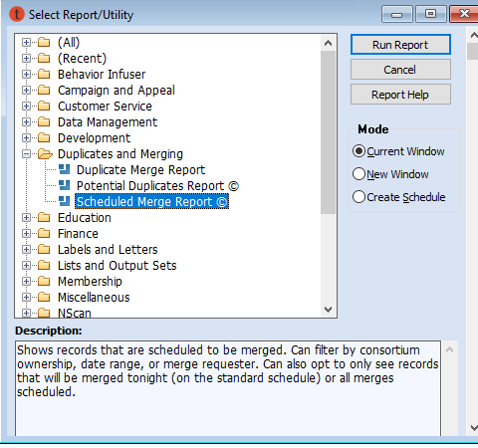

Enter the description of the new report:

Report Parameters
Parameters limit the type information on the report. See the example below for a complete list of parameters.
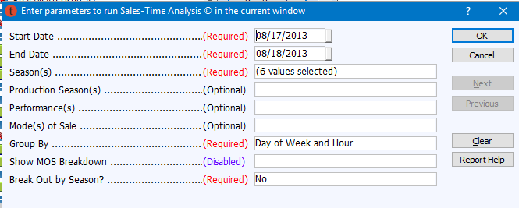

Enter the parameters for the new report:
 | Parameter | Required | Dropdown | Multi-Select
1)
2)
3)
4)
5)
6)
7)
8)
9)
10)

Output Fields
What information do you need the report to give you? In what order do you want to see that information? See the example below for a list of output fields.
 | Field Name | Description
1) | Customer #
2) | First Name
3) | Last Name
4) | Sort Name | Last / First
5) | Date of Pledge
6) | Contribution Amount | Total amount of pledge
7) | Received Amount | Total amount received to date
8) | Amount Due | Outstanding pledge amount

Please list the fields that you would like to see when you save the report as an Excel/CSV file.

 | Field Name | Description
1)
2)
3)
4)
5)
6)
7)
8)
9)
10)
11)
12)
13)
14)
15)

Format & Navigation
When saved as an Excel file, would you prefer to see the data exactly as it appears on the screen (formatted) or the raw data (a la CSV)?

User Groups
List the User Groups who will use this report:

Org Admin
Basic
Development Admin
Development
Education Admin
Education
Executive
Front of House

Group Sales
Intern
Marketing
Special Events
Telemarketing
Ticketing Admin
Ticketing
Volunteers

Sample Report
A picture is worth a thousand words. Creating a sample report of how you want the report to look will give a better idea of what information you’re hoping to get and the format that you need. Sample reports can be created in Microsoft Excel, Paint, Publisher, etc. See the example below for a good sample report.

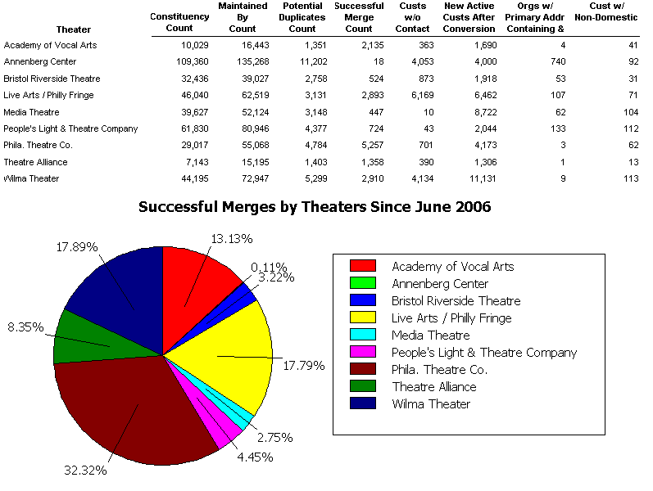

Did you remember to create and attach a sample report to the request?
(Please note that this report request will not be processed until the sample report has been submitted.)

