Tessitura 102
Constituent Management Standards
A short guide to all you need to know about updating basic constituent information.
Tegan Ketchie, Woodruff Arts Center
12/1/2015

Tessitura 102:
Constituent Management Standards

Table of Contents

How to Add a Patron to Tessitura pg. 3
How to Add a Spouse to a Household pg. 5
How to Add a Child to a Household pg. 7
How to Add an Employee to a Corporation or School pg. 8
How to Add & Update Contact Information pg. 10
How to Mark a Patron as Deceased pg. 11
How to Remove a Patron from a Household pg. 12
How to Remove a Patron from a Corporate Record pg. 13
“Don’t Call Me Anymore!”: Adding Privacy Settings to Records pg. 13
How to Identify Duplicate Records pg. 14
How to Avoid Creating Duplicate Records using Aliases pg. 15
How to Merge Records pg. 16

How to Add a Patron to Tessitura
Step 1. Search for the constituent you’d like to add by name, phone number, email, address – anything you’ve got! (Hint: You can search for fancy stuff like email and phone by using the “Advanced” search option as shown below. If you’re a beginning user, I’ve found the “basic” search to be easier to understand out of the gate.)
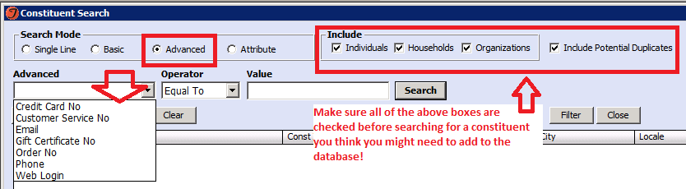
(Note: A search doesn’t have to be a full name or address. For example, if you’re searching for “Tegan Ketchie”, but you don’t know how to spell Tegan, “Ketchie, Te” is a fine search – chances are you might even find duplicate records! In the same way, a search for 1234 Pinetree Rd would be fine to search by “1234 Pine”.)

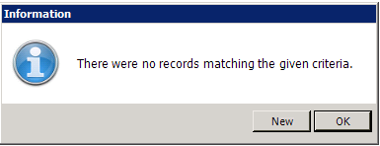
Step 2. If nothing comes up when you’ve searched for the patron once, choose “Ok” to the message (right). If you’re finished with multiple searches based on info you have (phone, email address, home address, name) choose “New” when this message appears.

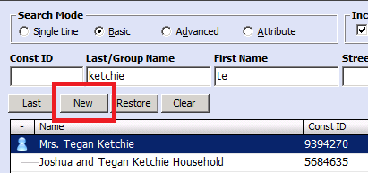
Alternate Step 2. Sometimes information is returned, but is not the patron you’re looking for. In that case, you won’t get the above message, but the “New” button on your search screen will now be black and available to select when your search is complete. See left.

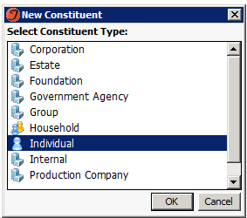
Step 3. Choose the “New” button, and determine what kind of new record you need in the popup screen as shown, right. (Household hint: If you are creating a new couple, where neither partner is in the database already, choose Household. If it’s a single individual, choose individual.)

Step 4. Fill out required patron information, as shown below. Right now, WAC procedures dictate that addresses are required to create a new record. If you really don’t have anything (no business address, no nothing), write “Bad Address” in the text field for Address Line 1 and flag the record as a “Bad Address” in the “Mail Restriction” section in the lower righthand corner.
Note: Email addresses are added in a separate screen on the “Contact Details” tab. See “How to Add Contact Information” for more details here.
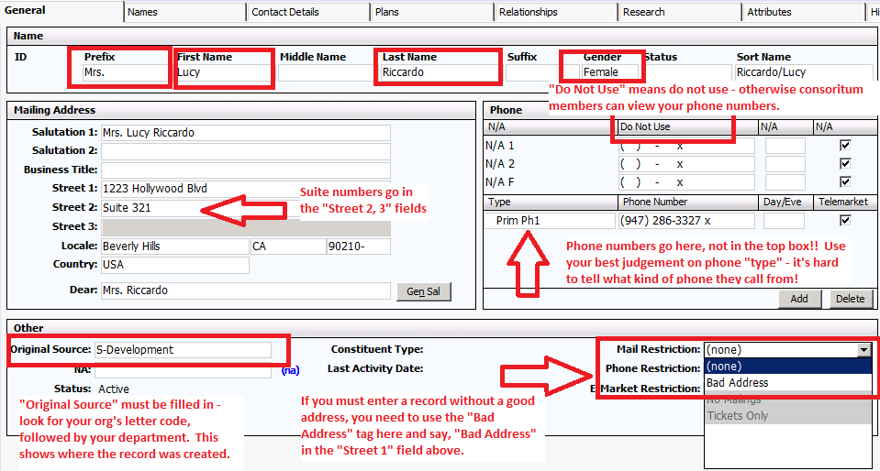
Step 5. You’re done! When you close out of the record, it will prompt you to save.

How to Add a Spouse to a Household
If you have an existing single person and would like to add a spouse or partner to the record, here’s how!
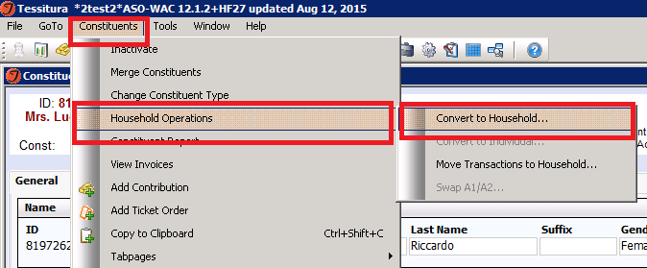
Step 1. Convert the Individual record to a Household account. From inside the individual’s account, choose the following menu options:

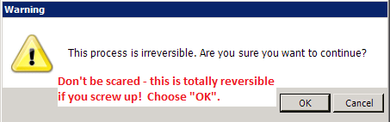
Step 2. Select the following options from the popup menu. You are essentially making Lucy Ricardo’s current account the new household record, and creating a new (linked) record for Lucy – you’ll create Ricky’s in a moment:
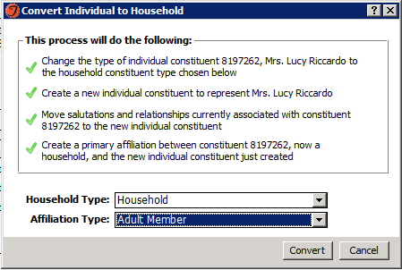

Step 3. Now create Ricky’s record by “Adding Affiliate” to the top of the new household record. Be sure to add a salutation (Mr. / Mrs.) and A2 – the A2 is important to mark this as a primary member of the household.
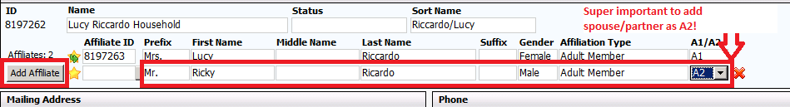
Step 4. Choose “File” then “Save” to save Ricky as the newest member of the household.
Step 5. But wait – the salutation is wrong!! Choose “Gen Sal” on the general tab to update the record to include both individuals.
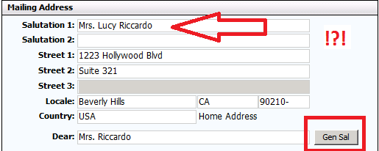 And the results are…..not good.
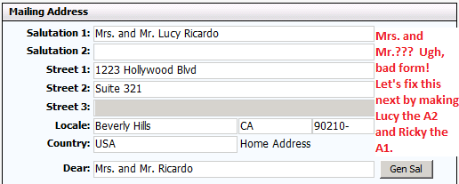
Step 6. Switch the constituents so that Lucy is the A2 and Ricky is the A1.
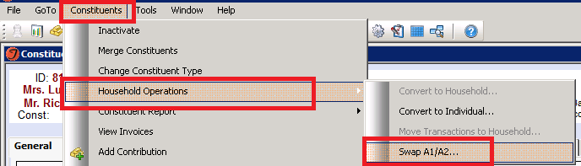

How to Add a Child to a Household
Step 1. In the household record, go to the “relationship” tab and select “Add Affiliation” at the bottom left corner.
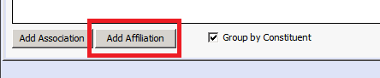
Step 2. When the screen below pops up, choose “Create Constituent” instead of typing in the name info immediately. This will create a new constituent record for the child you’re adding who will share the parents’ contact information.
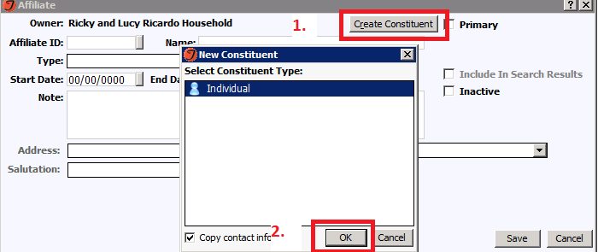
Step 3. Since you checked the box “Copy contact info” in the screen just now (see above), you won’t need to add anything except the child’s name.
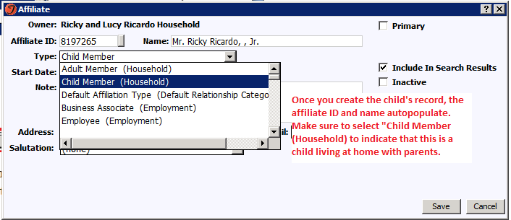
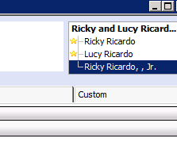
Step 4. You’re on the household record now. Go to the child’s record to mark it with an “attribute code” to note that he/she is under 18 and should not be a lead used for marketing. To toggle between patron records from the household record, choose the child from the top right corner of your screen. Now go to the “Attributes” tab and select “Add” at the bottom left corner of the screen. **Note: Attribute code is not yet created – stay tuned for the code to be used.**

How to Add an Employee to a Corporation or School
Step 1. Search for the School or Corporation to which you want to add an employee. There are many old duplicates in the system (in process on data cleanup!), so follow this rule of thumb to determine the “right” one.
For Corporations, the record with the most Constituency codes wins!
For Schools, the record with the “DOE” Constituency code wins!
Step 2. In the corporate record, go to the “Relationships” tab and choose “Add Affiliation.” Find the employee in the database. If they don’t exist already, choose “Create Constituent” and follow the steps outlined on page 7 to create a constituent from here.
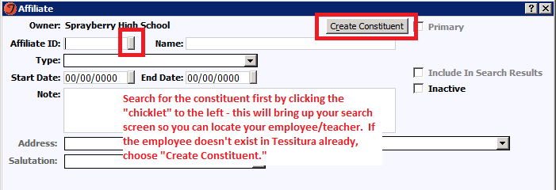
Step 3. Choose what “Type” of relationship the business entity has with your individual. Follow these general guidelines:
- If your individual is a teacher at a school, choose the “Teacher/School” type.
- If your individual works for a corporation like Coca-Cola and is a primary contact point for the Woodruff Center, use “WAC Main.”
- If your individual works for a school as a principal, choose “Principal/School.”
- Otherwise, use the example that makes the most sense to you.
Step 4. If you know anything further about the person’s relationship with the organization, put it under “Title” so it will show up on the relationship tab without you having to click in to the individual, as shown below.
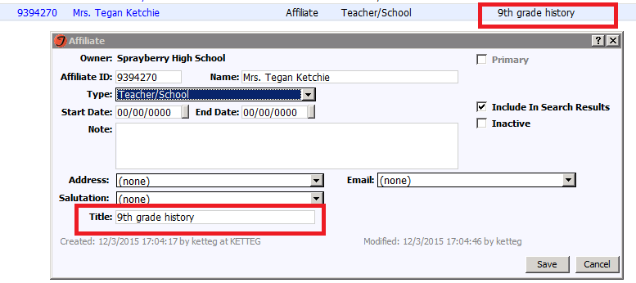

How to Add & Update Contact Information
Addresses:
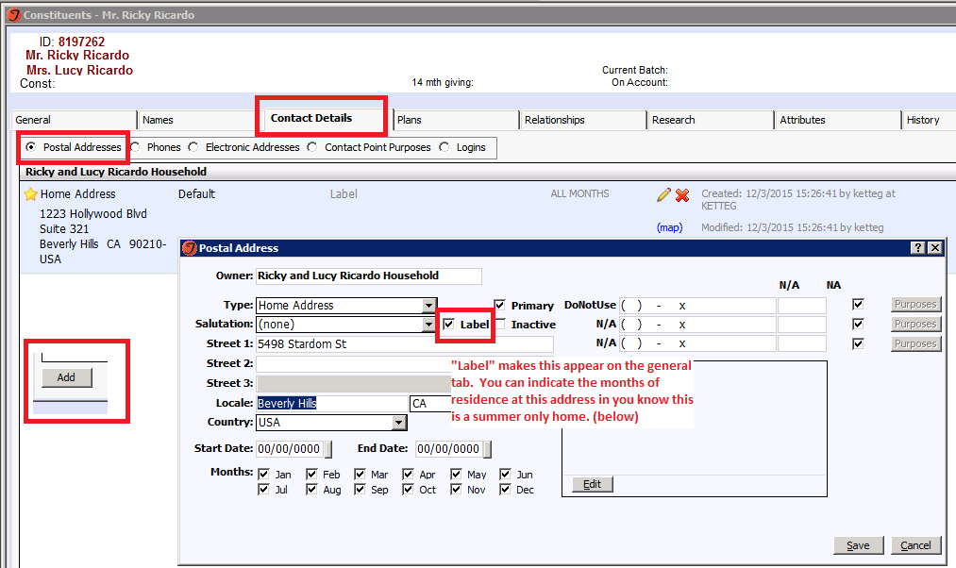
- Never update an address on the “General Tab” – always update on the “Contact Details” tab. We like to keep the historical record of addresses (helps us identify potential duplicate records). See below.

Phones:
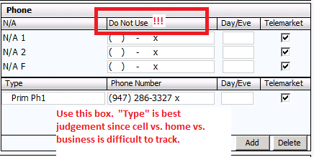
- These can be updated on the general tab. NOT in the box that says “Do Not Use” – anything you put here is viewable by the entire consortium (phones put in the bottom section ARE viewable across the whole Woodruff campus).

- It’s a good idea to keep all the phone numbers on the household record so you can see them easily at a glance, but not required.

- “Type” is up to your judgment since it’s tough to tell whether a phone is a home, cell, or business.

- You may or may not have access to “Delete” a phone number. There’s no point to keeping this info, so if you have delete rights, go for it! If not, make sure to change the “Type” to “Disconnected.”
Emails:
- Updated under “Contact Details” tab in the “Electronic Addresses” section.
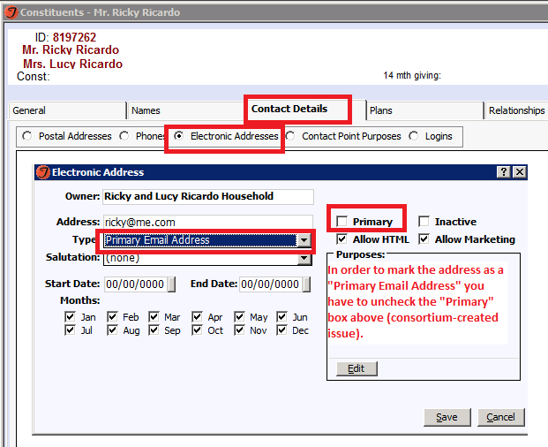

How to Mark a Patron as Deceased
Step 1. Find the obituary for the individual via google search. If you can’t find one (this rarely happens), document what you heard that caused you to take action on this.
Step 2. Place the obituary in the “Notes” section of the deceased patron’s record. The Note type must be “Obituary” with no letter code preceding it. This way, the entire consortium has access to this note for reference.
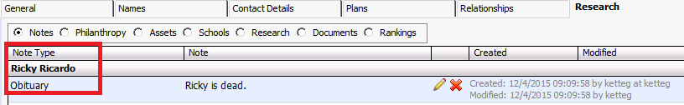
Step 3. On the “General” tab, mark the “status” as “deceased” in the individual record. Tessitura won’t let you do this on the household record for an individual, BUT if both patrons are deceased, go ahead and mark the whole household as “deceased.”
Step 4. Go to the household record. If the deceased patron still appears on top in the household record (the A1 slot), go to the “Constituents” drop down menu and choose “Household Operations” and “Swap A1/A2”.
Step 5. Check ALL salutations to be sure that the deceased won’t be referenced in mailings. This is something a representative from ALL organizations needs to check since we all have so many “private” salutations listed. This is in the “Names” tab and “Salutations” section.
Step 6. On the “General” tab on the household record, choose “Gen Sal” to update the record.
Step 7. Go to the “Constituent” menu while in the deceased person’s record and choose “Inactivate.” If the whole household is now deceased, do the same with the household record.
Step 8. Email the “Tessitura Power Users” group with the patron ID and name to let them know that individual has passed away and that they should check their individual salutations.
How to Remove a Patron from a Household
Step 1. Determine which member of the household should get all the household data. Then follow steps 2 and 3 below for the person NOT receiving household data.
Step 2. Update the address info for the person you are removing by going to the individual’s record and creating a new address under the “Contact Details” tab. You must do this even if new address is the same. Check the “Primary” box.
Step 3. If the person you are removing is in the A1 slot of the household, go to the “Constituents” drop down menu, choose “Household Operations”, then “Swap A1/A2.”
Step 4. On the household record, go to “Relationships” tab, and choose the red “x” by the name of the person leaving the household. In the same tab, add them back as an “association” (instead of the “affliation” you just deleted) under the association type “ex-spouse.”
Step 5. Merge the household record with the individual getting all the household data.

How to Remove a Patron from a Corporate Record
Step 1. Just delete their “affliation” from the “Relationships” tab in Tessitura by clicking on the red “x” to the right of their name. If you just want to inactivate while keeping the history, open the affiliation and choose the box that says “Inactivate.” If you can’t do it due to security restrictions, ask a Power User.

“Don’t Call Me Anymore!”: How to Add Privacy Settings to Records
Step 1. In the household record, go to the “Attributes” tab, then choose “Attributes” radio button. “Add” a new attribute that begins with your org’s letter code (S=Symphony; M=High Museum; T=Alliance Theatre; W= Woodruff). The “S-Privacy” attribute belongs to the Symphony. You can add as many of these Privacy settings as you need – each choice in the dropdown menu will require a new attribute line, so keep picking them up until your account has the appropriate settings.
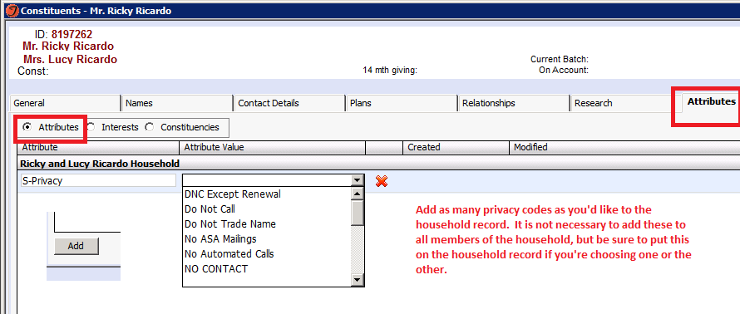

How to Identify Duplicate Records
Step 1. Is this a duplicate record?

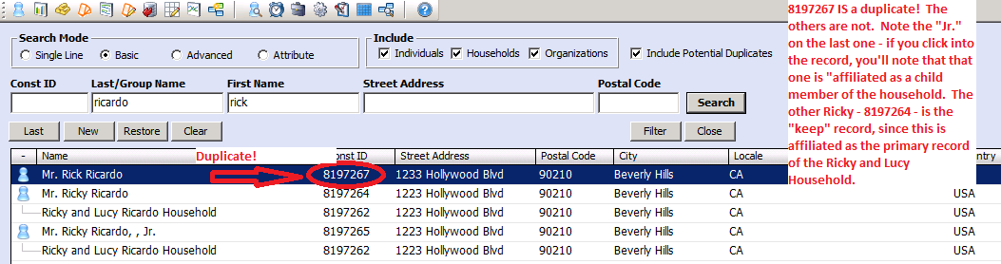

In the household model, a couple will have 3 records – 2 individual records and one shared household record. If you don’t see an individual with a ‘dotted line’ relationship to a household in your search screen, chances are that individual is a duplicate record. Note the constituent IDs as well. In the example above, the Ricky and Lucy Ricardo household is shown twice, with the same Patron ID – it’s the same record, shown twice to show you the relationship of the other individuals to the household!

Step 2. Once you’ve determined that you have a duplicate record, ask yourself whether or not the records should be merged. Here’s how:

- Are the names exactly the same, or close to?
  - Names must be exactly the same, barring obvious misspellings, or confirmation from patron
  - If you have a Bob Smith and a Lisa Smith at the same address, different IDs, it is NOT a fair assumption that they are spouses and should be a household, unless you have confirm from the patron or strong reason to believe they are – they could be divorced, parent/child, coincidentally share the same last name, etc.
  - WHEN IN DOUBT DO NOT MERGE

- Are the addresses the same, or close to?
  - Addresses may be in different formats, misspelled, YELLED IN CAPITAL LETTERS, etc. (Lazy man’s merge keeps the ID that has the appropriate capitalization, formatting)
  - If addresses are NOT the same, check the email addresses, phone numbers. Do they match across records? If you’re feeling ambitious, confirm at whitepages.com! If so, is there a reason they might want to keep these records separate?
  - WHEN IN DOUBT DO NOT MERGE (ex. Bob Smith lives at 123 Symphony Street and 321 Symphony Street – Hey, it’s possible!)

- Which constituent record should I keep and which should be deleted?
  - General rule: Longest constituency string wins, with some exceptions, as below

What special cases should throw up red flags before I merge?
- Deceased patrons: they WILL reanimate if you merge them, regardless of which ID you delete; mark all records you are merging as deceased BEFORE you merge
- Inactive (grey-ed out) patrons: You have to remember to activate-merge-re-inactivate the next day – otherwise, we waste time and money contacting patrons who have died, moved, are not interested, etc.
- Any constituency code ending in “VP”: This means the patron is of high importance to someone (ballet, opera, WAC, High, Alliance, Symphony, Young Audiences, etc.) DO NOT MERGE these. Ask someone in the Power User distribution list to request permission from the consortium member who “owns” the VP
- Individuals who are also part of a household: Tessitura requires that you merge the single individual into the individual record associated with the household, NOT the household record – if you forget this, Tessitura won’t let you complete the merge.

Prevent Duplicate Records via Aliases
We know that Ricky and Lucy Ricardo are actually Desi Arnaz and Lucille Ball, right? So let’s make sure Tessitura knows that too!
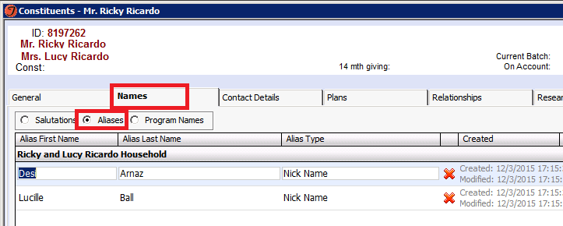
Step 1. On the household account, go to the “Names” tab and add a Nickname to each account. This way, when you search for Desi Arnaz, now Ricky Ricardo’s record will pop up!
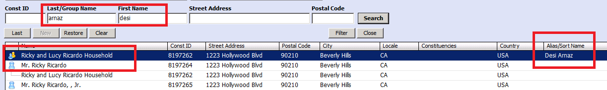

How to Merge Records
Step 1. Go to the “Constituent” Menu, and choose “Merge Constituents”

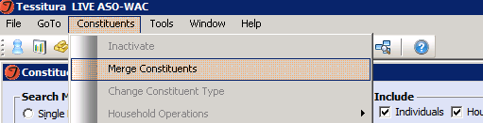

Step 2. Fill in the “Keep ID” and “Delete ID” fields. If you wrote down the IDs to keep and the IDs to delete, type them in the boxes below. Otherwise, you can choose the circled “chicklets”, below, to search for your constituent again!
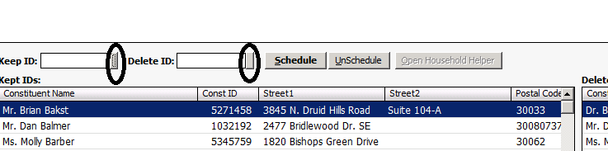
“Unschedule”: The oops card! Highlight your bad merge in the screen below, and choose unschedule to “undo” the scheduled merge. Good only for the day you merge – if you wait until the day after, you’re fired!

Step 3. Choose “Schedule” – and your two IDs will merge overnight! Just like that.

