Commonly Requested Lists and Output Sets for Marketing / Ticketing

“How do I know if I want a list (versus a report, or an extraction, or T-Stats)?”
You want a list if:
- You’re only looking for one or two criteria
  - ie. A list of ticket buyers to a specific season(s) or specific performance(s)
  - ie. A list of ticket buyers to a specific season(s) or specific performance(s) who also gave to a specific campaign(s)
- You plan on using your list for a quick lookup of numbers and/or individuals, NOT for contact purposes

Use these alternatives if:
- Extractions
  - You’re trying to market to a large group: You MUST use extractions here to remove all “no contact” individuals and groups
- T-Stats
  - You want to compare your campaign progress against last year’s campaign progress
  - You want a pretty chart
- Reports
  - You want to know how much money a particular appeal brought in
  - If your list is a complicated request (ie. More than 3 requirements), check for a report that might meet your needs more quickly
  - If you want a lot of complex information in Excel: contact info, giving history, ticket history, activity history

Now that you’ve decided you need a list: Here’s the big picture process!

Step 1. 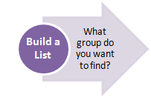

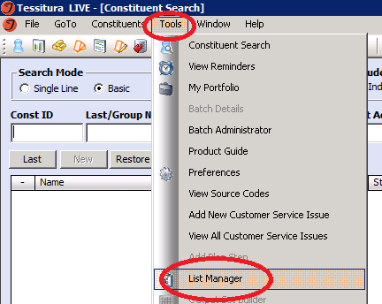
    - To get to your List Manager, open Tessitura. Choose the “Tools” Menu option, then “List Manager” from the dropdown menu.

    - Click “New List” at the bottom of your screen to start building! Here are some sample recipes:

Ticket Buyers to a given performance date
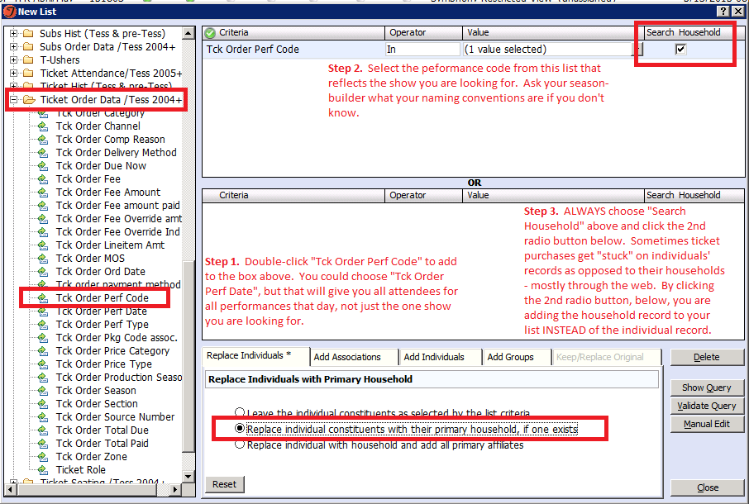

Current subscribers
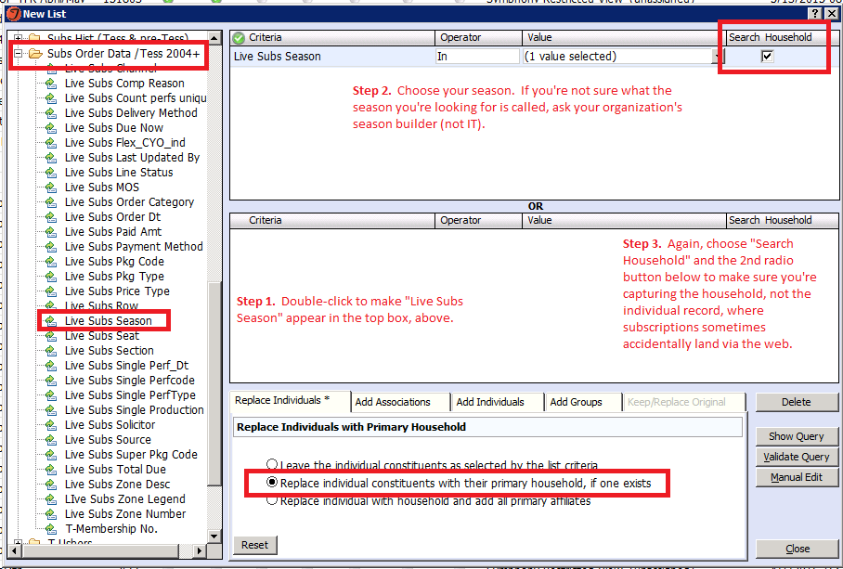
Ticket Buyers by Source Code
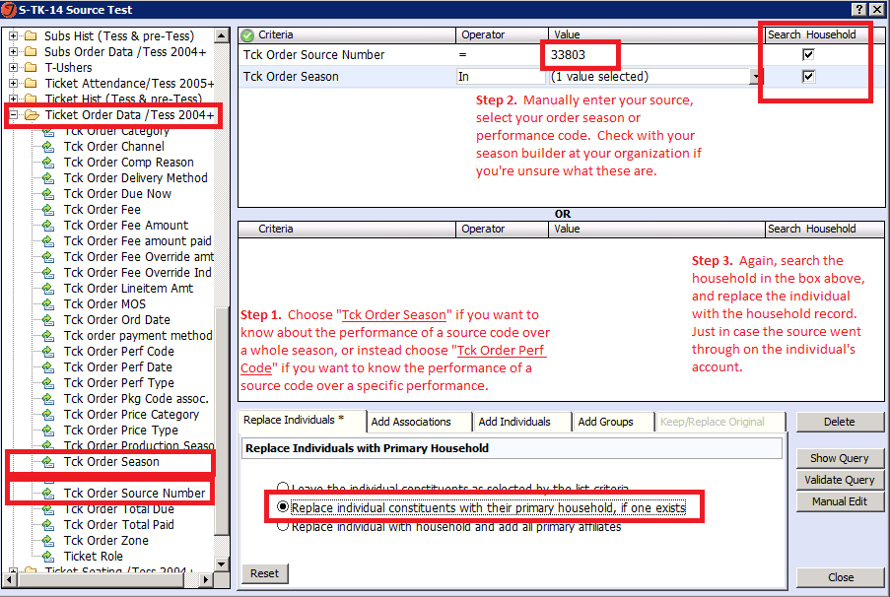

    - Save and close your list
- Choose “Close” at the bottom righthand corner of your window
- Select “Yes” you would like to save your list when prompted
- Name your list. We have a naming convention for ALL lists!:
    - Your organization’s letter code *dash* your initials *dash* fiscal year *space* whatever you want to name your list. Mine for the Symphony would look like this: S-TK-16 Tegan’s List
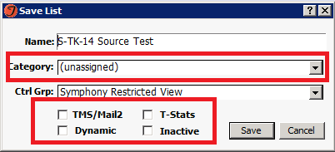
  - Here are some other cool options you have when saving your list:
TMS/Mail 2: Check this if you want your list to be available for use in either of these applications
T-Stats: Check this if you want to make this list available to use in your T-Stats reports
Dynamic: Choose this if you want your list to automatically regenerate every time it is pulled in a report or extraction or T-Stats
Inactive: Choose this if this is an old list you don’t want to delete, but want to appear at the bottom of your screen
Category: Use this to organize your list into a folder for easy access later. Not necessary, but can be useful.

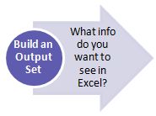

Step 2.

        - Build an Output Set to tell Tessitura what info you would like to see on each patron that pulls in your list. To get to your Output Set Builder, follow these steps:
          - Go to the “Tools” Menu, choose “Output Set Builder”
          - Choose “New Set” at the bottom of your screen
          - See the screenshot below for a list of the most popular output elements:

This is your Excel canvas. The elements listed below are in the order that they will appear from left to right columns in your finished Excel report. The Tessitura ID pulls in column A by default, so your first element below will be in column B.
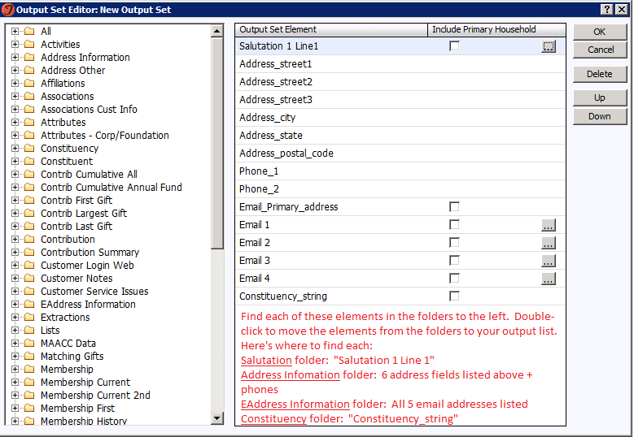
For example, “Salutation 1 Line 1” below will be column B, “Address_street1” will be column C, etc. You can rearrange these elements as you go by highlighting them and choosing the “Up” and “Down” buttons below.

What’s a “Constituency_string”? This lists all of the constituency codes that a patron has on their record. The constituency codes are the 3-digit sets of alphabet soup that appear in the header bar when looking at a record. This will pull ALL codes, not just the ones that the header has room to display when you’re in the record. Can be helpful for sorting types of people in Excel. Like below: 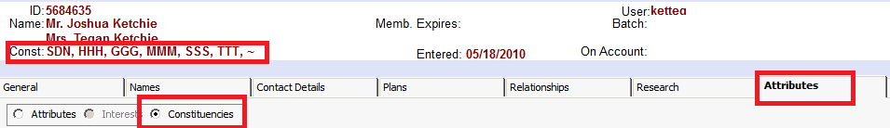
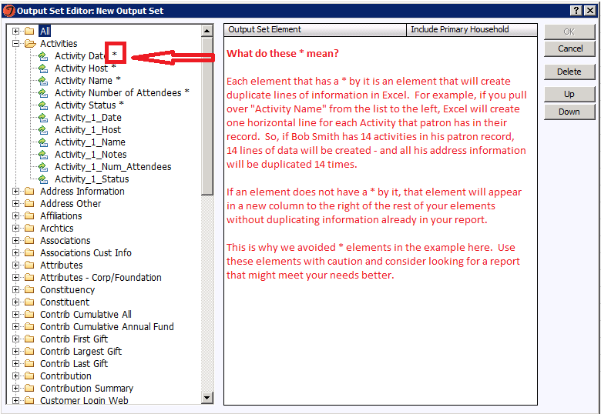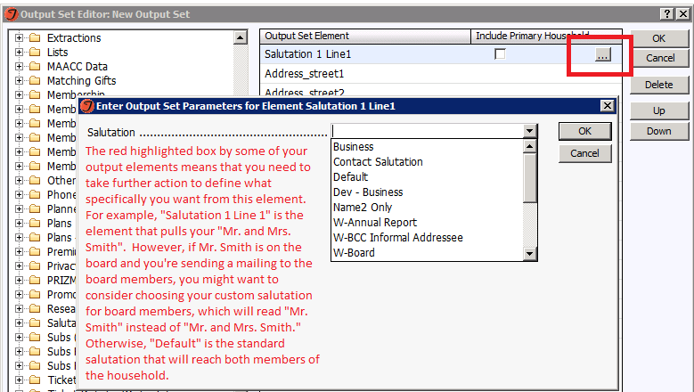
      - When you’re finished creating your Output Set, choose “OK”, then save your Output Set using the same naming convention you used for your list. Organization Letter Code *dash* Your Initials *dash* Fiscal Year *space* Name of Your List (Ie. “S-TK-16 Contact Information”)
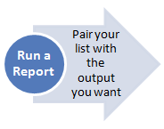

Step 3.
- Go to the “Go To” Menu at the top of your screen to access “Reports & Utilities”. From the Report screen, choose the folder “List Builder / Output Builder” and the report “Execute an Output Set”.
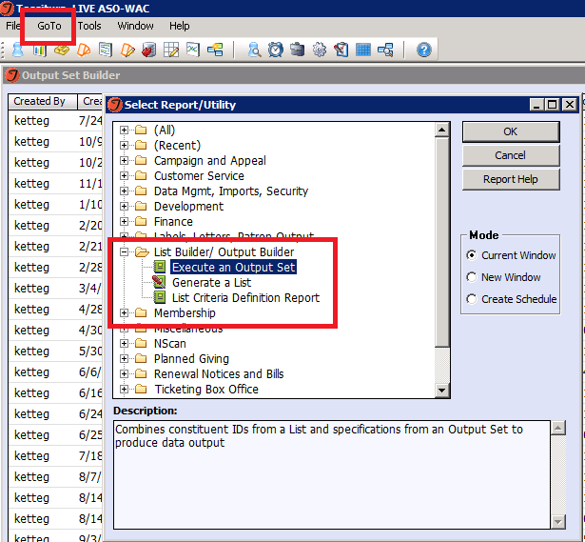

- Now, all you have to do is select your list and the output set you just created. If you used the naming convention, it makes it really easy to scroll to your stuff. (Hints: YOUR output sets appear at the top of the “Output Set” list – sometimes you have to scroll up to see them. For lists, choose the “chicklet” next to the arrow dropdown instead of the arrow – this takes you to your lists directly so you don’t have to sort through hundreds of someone else’s.)
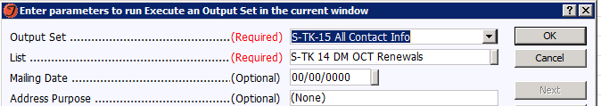

- C lick “OK” to run your report! Don’t worry – the report looks funny and is hard to scroll through. The next step is to save to Excel, where everything will look familiar.
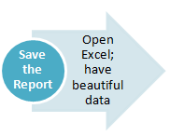
Step 4.
While your generated report is still up, follow these steps to save to Excel in either the shared drive (G drive), or your desktop.
To save to G drive:
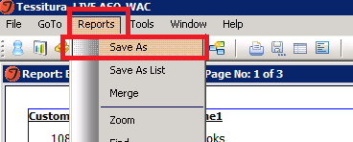
“Include Data Labels” provides a data header in line 1 of Excel – extremely helpful! You can save as a regular Excel file, or Comma Separated Value (CSV). CSV files are better for larger amounts of data since they compress the Excel file to take up less space. However, if you want to mark up your Excel file with pretty colors, a CSV won’t save these changes, so choose the XLSX option.
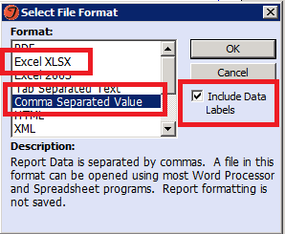
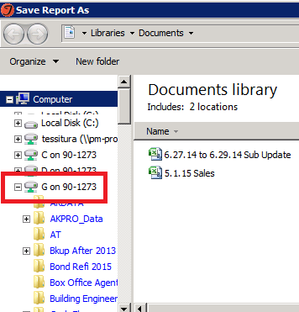

Congratulations! You’re Done! Now go find your file!

To save to desktop:
“Include Data Labels” provides a data header in line 1 of Excel – extremely helpful! You can save as a regular Excel file, or Comma Separated Value (CSV). CSV files are better for larger amounts of data since they compress the Excel file to take up less space. However, if you want to mark up your Excel file with pretty colors, a CSV won’t save these changes, so choose the XLSX option.



