Save the Customer Service Issue Tracking rerport as .xlsx and open the saved file.
Each question/parameter is separated by carriage return. This will be your delimiter so Excel knows how to split the data:
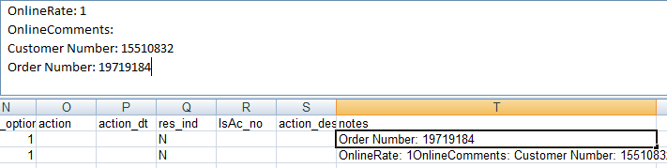
Insert columns to hold the split data – this example is columns U to X:
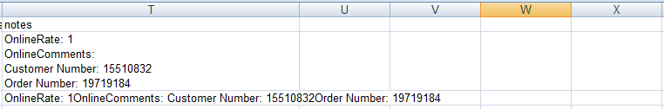
Highlight column to be split:
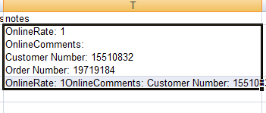
Go to DATA ribbon then select TEXT TO COLUMNS in the DATA TOOLS group.
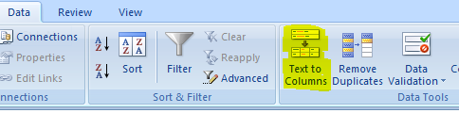
Select the DELIMITED radio button in the window then click NEXT.
Select OTHER as your delimiter and deselect TAB if that is already selected. Click in the box next to OTHER then press CTRL and J at the same time. This is a carriage return so Excel knows to where to split the data (it will look blank after you do this):
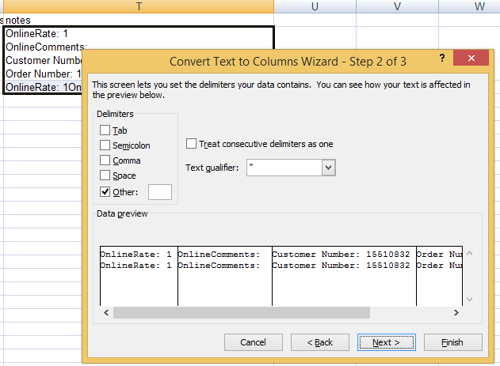
Click NEXT.
For the DESTINATION, make your selection the cells in the top row in the columns which will store the split data. In this example, it is U2:X2. Doing this lets you retain the original column:
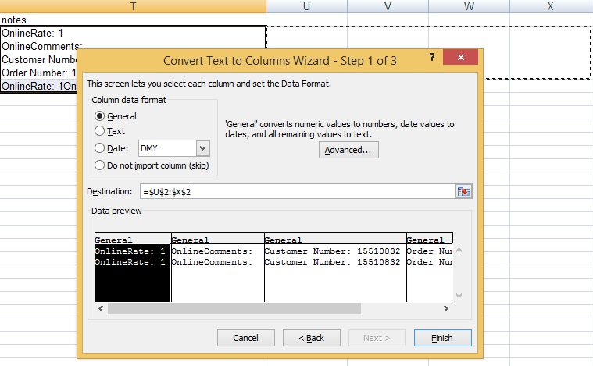
Click FINISH et voilà.
