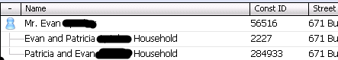
^From Constituent Search Screen
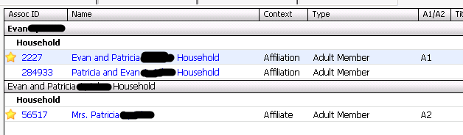
^From Relationships tab of Constituent screen

