Subscriptions Ranking

Overview 3
Reports 3
Rank Process 5
Subscription History 6
Memberships 9
Campaigns/Elevated Events 10
Constituency Rank 10
Special Consideration 11
Building Historical Rankings 11
System Setup 13
Store Procedures 13
System Tables 13
Reports 13

Overview

The subscription ranking process is based on the rankings spread sheet. At this time planned giving is not part of the ranking process.

Reports

There are two main reports that are used with the subscription ranking process. The first report “McCarter Build Sub Rankings” can be found under “Ticketing Subs Reports”. This report is used to build the current rankings for all the customers. This report has one parameter which is called “Historical”. If set to No the report will just build the current rankings. If set to Yes the report will update the historical rankings in the LT_CUST_HIST_RANK table. Running the report for historical purposes should be done once a year at season end. The report does not return any data; it just indicates when the report has finished running.

The second report “McCarter Subs Rankings Detail” is more of a proofing report used to help determine the rank points a customer has received. The report has one parameter which is that of the customer you would like to proof. The report does not update the customer’s rankings, it is however a current calculation. It may be the case that the rankings the report may not sync with what is in the customer’s ranking tab. The rankings can be updated by running the “McCarter Build Sub Rankings” report.

This report is organized by first Historical points, then by season and within season the items that a customer will received rank points for.
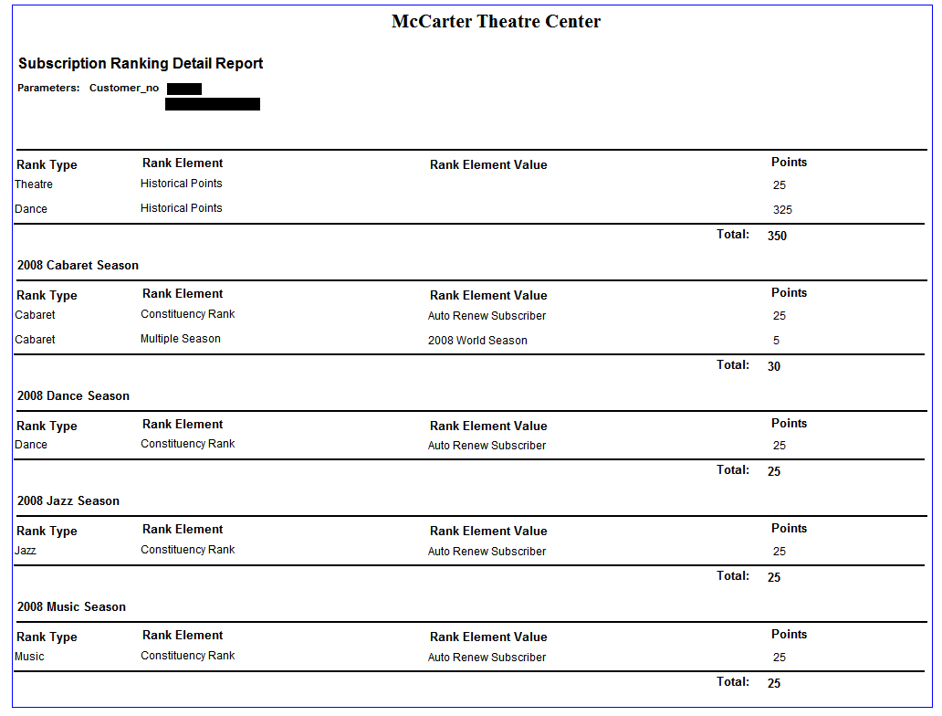

When proofing the report to what is in the Rankings tab for a customers, take the total for a rank type/season and add the historical points that have the same Rank type.

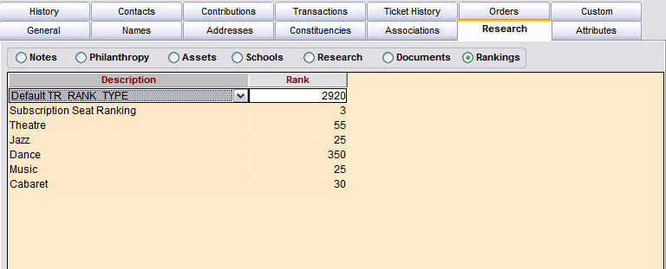

Rank Process
The main factors in the rank process are subscription history, package and price type, constituencies, memberships, campaigns/elevated events, and special consideration. The ranks to be used in the process should first be setup in TR_RANK_TYPE.

Subscription History
The setup table LTR_SEASON_RANK controls what seasons and for what rank types points will be calculated. Here you would setup each season and its corresponding rank type. The point’s field can be any value but at the moment we are setting it to zero because there is not a requirement for points to be added at this time.

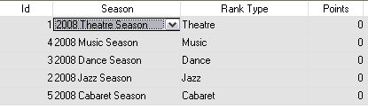

The rank process uses subscription history information found in T_SUBSCRIPTION_HIST for calculating which subscriptions, packages and price types a customer has and the points related to each.

Calculating multiple concurrent seasons and the points related to each is accomplished by setting up the LTR_MULTI_SEASON_RANK set up table. In this table we setup the current season to calculate for, the rank type the points should be applied to, the concurrent season(s) and the point value for each.

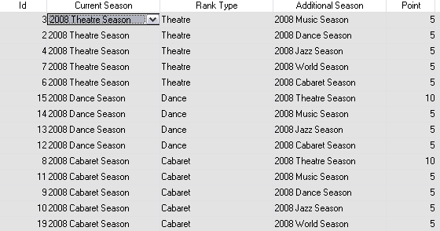

Package and package price ranking is set up in the package set screen. In the case of super packages the setup is only done at the super package level.

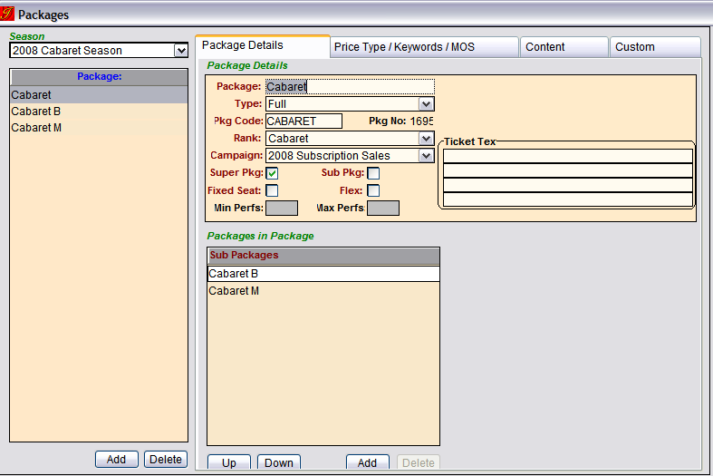

The rank type should match what has been setup in the main season ranking table (LTR_SEASON_RANK). To setup a price type ranking for the package a new custom tab has been added.
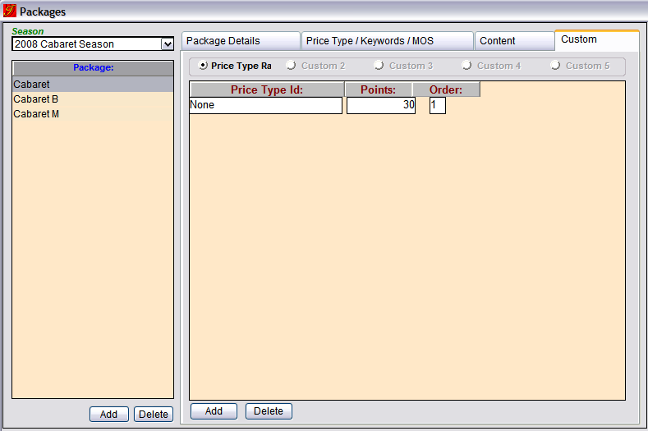

When setting up the price type ranks the “None” value acts as a catch all for all the price types. If another price type is added, that rank will be used when a customer only has that price type sold to it. In that case you add more price types the rank process uses the order column to decide which point value a customer should receive.

For example:
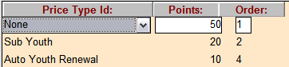

Price Type(s) Points
Price Type not in list 50
(Sub Full)

“Sub Full” and “Sub Youth” 50

“Sub Youth” 20

“Auto Youth Renewal” 10
“Sub Youth” and “Auto Youth Renewal” 20

Memberships

Membership ranking is based on the customer’s current membership record, the status of the record, the membership organization, and the level. The setup table LTR_MEMB_RANK is where the point mapping is setup.

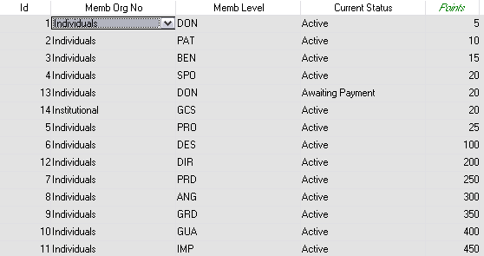

Now let’s look at a customer’s membership records and see how the points would be calculated.

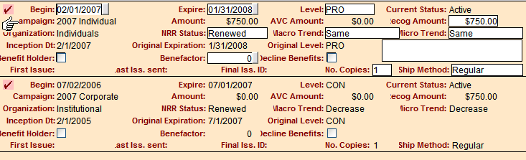
This customer would receive the PRO points of 25. If LTR_MEMB_RANK had an entry for the Institutional member organization, the customer would receive points for both. Points are added for the current membership record in each member organization that a customer may have.

Once the membership points are calculated for a customer, they are applied to each season and rank level that is setup in LTR_SEASON_RANK for the customer.

Campaigns/Elevated Events
Since campaigns and elevated events are both campaigns just different types, they are calculated similarly. The contribution table is used to calculated rank points. The setup table LTR_CAMPAIGN_RANK tells the rank process which campaigns/events should be used in calculating. The start and end amount columns are used in determining which points a customer should receive for there total contributions to the campaign.
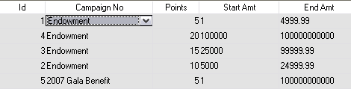

Once the points are calculated, they are then applied to each season and rank level that is setup in LTR_SEASON_RANK for the customer.

Constituency Rank
Rank points are added for each constituency a customer has on there record. The setup table LTR_CONSTITUENCY_RANK tells the rank process which constituencies should be considered and the point value associated with each.

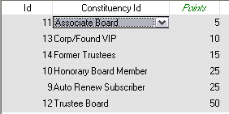
Once the points are calculated, they are then applied to each season and rank level that is setup in LTR_SEASON_RANK for the customer.

Special Consideration
Special consideration is points that you add to a customer to bump there rank points up when the process calculates the point values. This is setup on the customer record, in the custom tab called “Special Ranking”.

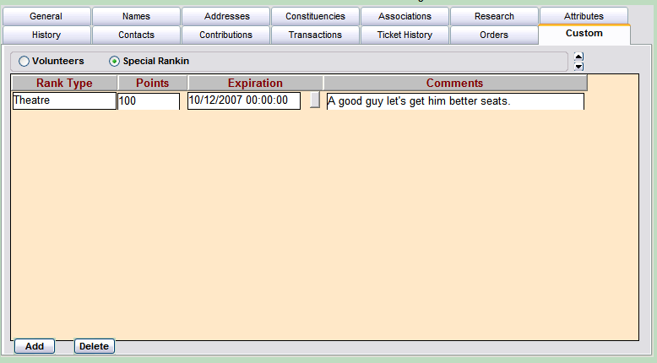

In the custom screen you would add the rank type, the extra points to be added, an optional expiration date, and an optional comment. If the expiration date is not entered the points will not expire and continue to be added until expiration is added or the entry is removed.

Once the points are calculated, they are then applied to each season and rank level that is setup in LTR_SEASON_RANK for the customer.

Building Historical Rankings
At the end of the season historical rank points should be built before changing the setup tables to reflect the new seasons. This can be done in Tessitura by running the “McCarter Build Sub Rankings” report with the historical value set to “Y”. Running this report more than once a year with the historical value set to “Y” will cause unwanted increases in historical rank point values.

System Setup

Store Procedures
LP_BUILD_CURRENT_RANKINGS – Builds the current rankings for all customers. This report has one parameter historical. If set to Y then it will build new historical rank points.

LP_CURRENT_RANKING_DETAILS – Stored procedures used to display all ranking considerations for the specified customer. This report has one parameter customer_no.

LP_UPDATE_SUBS_HIST - This procedure was updated to put price type information in the location column.

System Tables
LTR_SEASON_RANK – Main table used to determine for which season and rank type points should be calculated for.

LTR_MULTI_SEASON_RANK – Setup table used to map out which concurrent seasons points will be calculated for.

LTR_CAMPAING_RANK – Setup table used to determine which campaigns/ elevated events should be calculated for and the rank type.

LTR_CONSTITUENCY_RANK – Setup table used to determine which constituency rank points should be calculated for and the rank type.

LTR_MEMB_RANK – Setup table used to determine which memberships rank points should be added for.

LT_CUST_SPECIAL_RANK – Table used for custom tab “SPECIAL Ranking”. This table stores special consideration rank points for customers.

LT_PACKAGE_PT_RANK – This table is used to populate the “Price Type Rank” custom table in the package setup screen.

LT_CUST_HIST_RANK – Table used to store historical rank values for customers.

Reports
McCarter Sub Ranking Details – Report used to proof the current rank points for a customer. One parameter which is the customer number to proof.

McCarter Build Sub Rankings – Report used to rebuild the current ranking or rebuild the ranking history for all customers.

