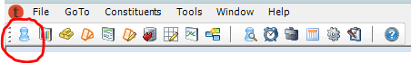
- Click on the Constituents icon. (Blue Gummy)

- Search and locate the correct constituent, Double click on the Constituent name and bring up the Constituent record. (See Finding A Constituent).
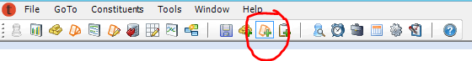
- On general Tab verify we have the correct address, email, and phone number. *Refer to our Style Guide to ensure the address is formatted properly.
- Add Ticket Order (Orange ticket icon with green +)

- For single ticket orders, you must always enter the following information:
Source: #### Channel: Phone
MOS: Box Office Delivery: E-Tickets
- Click the Product Catalog tab towards the top of the screen which loads in a calendar view.
- Right-click the performance name/date requested and select Add Order to Basket.
- Click the Seat Map tab and choose seats for the Constituent. This will populate the Zone and amount of tickets purchased.
- Click the Order Details tab to return to the original order screen
- Click Sub Line Items to read back to the guest their order.
- Ask if they would like to become a member or make a donation. Confirm their total
Confirming and completing the order in the Order Screen:
- Make sure you have entered the
Source: #### MOS: Box Office Channel: Phone Delivery :E-Tickets

- Click on the Green Money Bag and continue with the appropriate Payment method. (See Payment Methods Section). Make sure that the Total Due is $0.00 at the bottom of the order screen. If there is still a balance due, it indicates the payment may not have been processed correctly. Retrace your steps to find why there is a balance on the order.

Confirmation Emails and Printing:
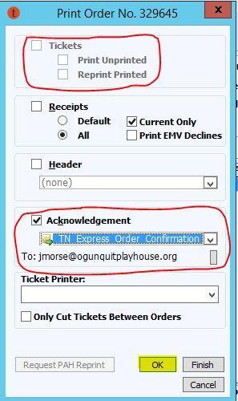
- Click the Print Order button at the bottom of the screen. (See Printing Tickets/Receipt Instructions)

Printing Tickets: Ensure the Tickets Box is unchecked.

Sending Email Confirmations: Click Acknowledgement. From the drop down menu, choose TN_Express_Order_Confirmation. Confirm that this is the correct email. Click OK to send.

- ORDER NOTE: 0/0: 2 tix to SHOW. Explained tix, emailed receipt.-Initials

- Once you have “printed tickets” and sent a confirmation/given a receipt, you may finish the order. Click DONE to save and close. If you do not Done the order, everything will be lost and the order will not have processed. Do not forget to hit Done at the end of all transactions.

