Single Search mode
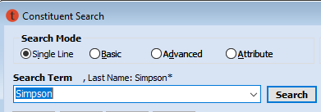
The optimal way to do a constituent search is by LAST NAME for names that are uncommon, or LAST NAME + ZIP CODE to narrow the results. Add a FIRST INITIAL for very common last names. Avoid using full first names which might exclude nicknames in the results.

Practice: constituent search
The above search example on “Simpson” returned 245 results, far too many to effectively narrow down. In Tessitura TEST, search Last Name + Zip code: Simpson 56087. You should correctly find the correct patron:
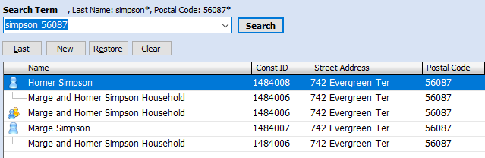
Notice the search results return the Marge and Homer Simpson Household, as well as the individual records for Marge and for Homer, both of which are connected to the household.
POLICY: When a patron is part of a Household, the transaction should be made on the household record, unless the patron requests otherwise.

Finally, why not search for full names? Say the above patrons calls and identifies herself as “Marjorie Simpson.” Try searching for it in TEST. You will not find the record and will end up creating a duplicate.

Single Search Interpretations
- A number by itself = Constituent ID
- A single name = Last Name
- An initial followed by a name = First Initial + Last Name
- Two names = First Name + Last Name
- A search term that contains @ = Email Address
- A number that begins with # = Phone Number (dashes are optional)

-----------------------------------------------------------------------------------------------------------

Creating a new constituent record
Before creating a new constituent record always do a thorough search (best using LAST NAME + ZIP CODE) to avoid creating duplicate accounts. If no results are found you will be notified by a dialog window; click [New] and select Individual in the next window that opens, then click [OK] to open the General Tab of the next constituent record.

Practice: create a new constituent record for a favorite fictional character in Tessitura TEST following the steps below:
- Name
- The name you search on will populate the Name fields; complete as needed
- Skip the Prefix, Middle Name, and Suffix fields unless the patron specifies otherwise
- The Gender and Status fields can be left blank
- The Sort Name is automatically generated and is used in search results

- Mailing Address
- The Salutation 1 and Dear fields will auto populate based on the Names fields
- Street 1: Type the patron’s address here including apartment numbers.
- Street 2 is used only for building names or wings. Street 3 is inactive.
- The Locale: fields are automatically populated based on the zip code you used in constituent search. If the city name differs from the name the patron gives you, change it to their preference.
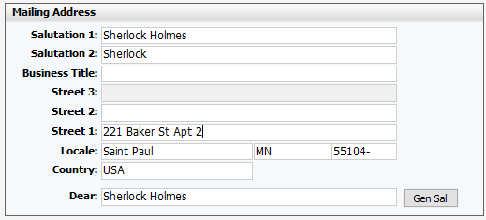

- Phone Field
- Primary is the best number to reach the patron – whether home, cell, or work.
- If they want to give you a second number, enter it in the Secondary Phone field.
- Ignore the Day/Eve and Telemarket boxes

- Other fields
- Original Source: Box Office
- Email: enter current email address in all lower-case letters.

Address Standards
- Omit all punctuation
- Abbreviate STREET SUFFIXES (Ave, Blvd, St, Dr)
- Abbreviate DIRECTIONALS (E, S, NW, etc.)
- Do not abbreviate STREET NAMES and CITY NAMES (including “Saint”)
- Street names that are NUMBERS should NOT be spelled out:
Example: 324 E 2nd St NOT 324 E Second St
- APT and UNIT numbers should follow the street address. Do not use #. No
comma between street and apt/unit number.
Example: 123 Main St Apt 3B

---------------------------------------------------------------------------------------------------------------

The Basic Ticket Order

Step 1 – add the patron to the order

To access Constituent Search from the Ticket Order screen, click on the chicklet next to the Owner: field.
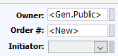

If the constituent ID is known, it can just be typed in the Owner field.
If a constituent record doesn’t exist, create a new one.
Double click on the desired constituent to add them to the order.

Step 2 – add the performance

Go to Product Catalog > Calendar View
Right click on the desired performance
Select Add to Order Basket

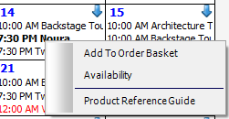

Step 3 – reserve seats
- Go to the Seat Map tab, locate the desired seat(s) on the map and click on it. The seat will turn yellow indicating that it is reserved.
To unselect a seat just click on it again.
- When finished reserving seats return to the Order Details tab to complete the order.
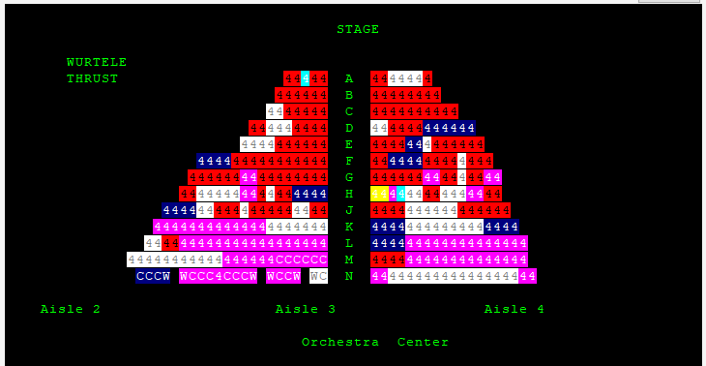

Step 4 – take payment
Open the Payment screen by clicking on the Payment button (the money bag icon) on the toolbar.
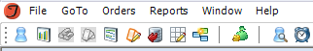

The Amount field displays the total amount due.
The Payment Method dropdown is populated with all available payment methods. Most phone order will be paid with a credit card.
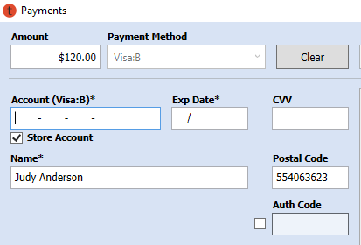
- Enter the credit card number in the Account field, without spaces or dashes.
- Enter the expiration date for the credit card. (Written in DD/YYYY)
- Enter the security code in the CVV field.
- Click the [Authorization] button and wait for the Authorization code.
- After receiving authorization, click [OK] to return to the Order Details screen.

Gift Certificates and Money on Account can also be used on phone orders, but we’ll cover those later in training.
Some patrons will ask if we have their credit card info saved on file. The answer is No, we don’t save their information due to security concerns.
TIP: The last order that you worked on can be reloaded by selecting Load Last Order from the Orders menu

Step 5 – complete the order header
The Source, Category, and Delivery fields all need to be filled before completing the order.
Source: A source can be entered directly into the Source field or selected from a list by clicking the chicklet. The general source code changes each season.
Category: The Category indicates what kind of order this is. Choosing the correct category from the dropdown will assist in searching for orders. Most of your phone order categories will be Single Tickets and Exchanges.
Delivery Method: Confirm with the patron how they would like to receive their tickets and then fill in the Delivery Method field.
- Standard Mail: there must be at least a week before the performance
- Hold at Box Office: tickets will be printed the day of show and held at Will Call
- E-Ticket: sent by email with an attached PDF of the tickets

Step 6 – wrap it up!
- Review the entire order with the patron: name & address; performance name/date/time; # of seats; total paid; delivery method.
- Tell the patron: “This is a final sale. There are no refunds or cancellations.”
- Click [Done] in the Order Footer. This will save the order to be printed in a batch, and clear the screen for the next order
Reviewing the order: It is helpful to come up with a “script” to make sure you are hitting all the points whenever you are ending a sale:
“Thank you for your order!
We have 2 tickets for Willy and Linda Loman for Cabaret on Friday, July 3 at 7:30pm
The total charge to your VISA is $156, which includes a $5 handling fee per ticket.
This is a final sale and there are no refunds or cancellations.
We’ll be mailing the tickets to 1948 Miller St NE, Minneapolis 55420.
Is there anything else I can help you with?”

