Adyen and Tessitura Reconciliation
Tessitura has provided a handy reconciliation helper tool, which is an Excel document with built in formulas and such that takes the manual labor out of the reconciliation process. It is possible to combine multiple Adyen batch files into one file so that you can reconcile multiple days at once. More on that process below.

Steps for reconciling with the helper tool
- You will need to download the helper tool from Tessitura Network. This only needs to be done once. Once you have a local copy of the tool you can use it again and again by just changing the files you are having it compare.
  - Read the instructions for first use tab for additional instruction before using this for the first time.
- Within Adyen, you will need to download the settlement details report(s) for the date range you are reconciling.
  - Go to “Finance” on the left hand side and click settlement details. You may need to look back at the last batch number that was reconciled to determine which batch(s) to download. Consult whomever last reconciled to learn the last batch # and date range, so you know where to pick up from.
- Within Tessitura, you will need to download the payment gateway summary/detail report for the same date range.
  - You may need to open the Adyen batch files to know which transaction date(s) to choose.
  - Save this file as a csv
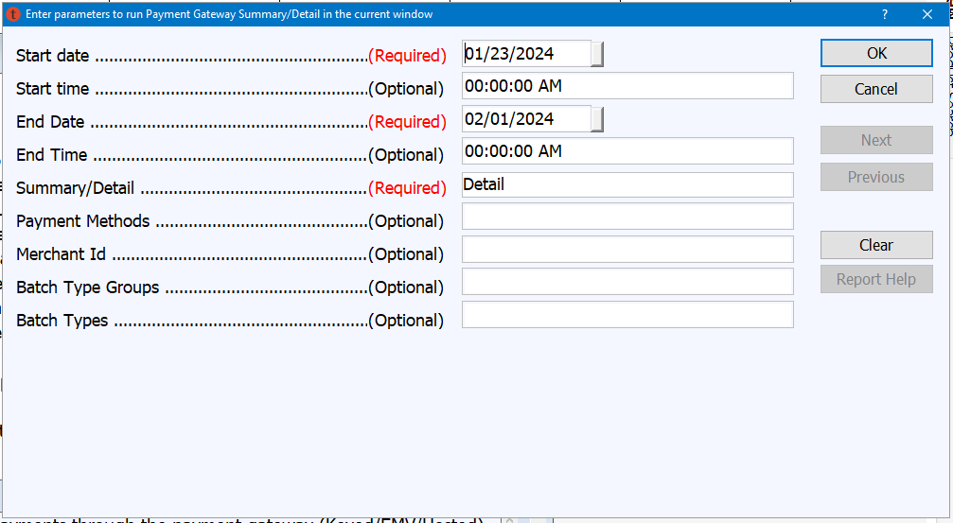
- In the helper tool:
  - Click on the red file icon to select the location of your Adyen file and Tessitura files in the two corresponding spots
  - 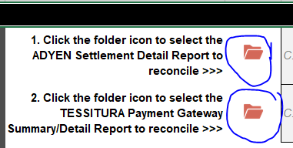
  - The refresh button that is built into the sheet may not work. Instead, click on the data tab and click refresh all
  - 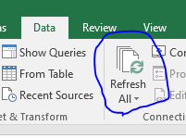

To reconcile multiple batches/days
- Combine adyen batches into a single csv
  - Save all batches in a single folder with no other files in it.
  - Open Excel (desktop version)
  - Click on the data tab
  - Click New Query, From File, From Folder
  - Select the folder you saved your batches in, click ok, then click combine and load. Click ok.
  - Delete the extraneous sheet 1 and rename the newly created sheet as sheet 1.
  - Save as a csv.
- Follow steps 3-4 above, pulling the Tessitura report for the full data range represented by the multiple Adyen batches.

What to do if it doesn’t match
- Transactions in Tessitura but not Adyen
  - Look at the tab labeled Tessitura only transactions
  - If all of these are labeled “WEB Stripe credit card” you’re in the clear!
    - If you are a member of finance, download reports from Stripe to check that these numbers match what Stripe has paid out for the time period.
- Transactions in Adyen but not Tessitura
  - If the type cooresponds to a chargeback, we don’t need to worry about those. We don’t expect those to show up in Tessitura.
  - If it seems to be a standard transaction that just isn’t in Tessitura, it will need to be refunded in Adyen. Do some checking between Adyen and Tessitura to confirm it is an orphaned transaction before refunding in Adyen. Email the patron to inform them.
    - If a previous orphaned transaction was refunded in Adyen, it will also show up here, and you shouldn’t worry about it. Since it was only refunded in Adyen, we wouldn’t expect it to be in Tessitura.

