Perth Tessitura Consortium

Data Entry & Management Standards

Contents
Overview 5
Data Relationships and Visibility 5
Constituent-Company Relationships 5
Shared Data 5
Modification of Shared Data 5
General Standards – Constituent Data 6
Constituent Data Entry 6
Avoiding Duplicates 6
Data Entry: General Tab 6
Constituent Data: Names 6
Prefix 7
First/Middle/Last Names 7
Suffix 7
Gender 7
Status 7
Sort Name 7
A1/A2 8
Constituent Data: Mailing Addresses 8
Street 1 Field 8
Street 2 Field 8
Street 3 Field 8
Locale 9
State 9
Postcode 9
Country 9
Constituent Data: Phone & Email 9
Phone 1, Phone 2, Fax 9
Email 9
Mail/Phone/E-Market Restrictions 9
Constituent Data: Additional Tabs/Fields 9
Aliases 9
Households 9
Relationships 10
Salutations 10
Contact Details 11
Constituencies 11
Attributes 12
Contact Restriction Attributes 12
Organisation Data Entry 12
Holding Corporate Information on Individual Accounts 13
Relationship Based on Constituent’s Place of Employment 13
Constituent has an Individual Relationship with a Perth Tessitura Consortium Member but has Provided Business Address Details 14
Handling changes and removal of Organisational Contacts 14
Schools Data Entry 15
Government Contact Data Entry 15
Government Contacts 15
General Tab 16
Names Tab 16
Addresses Tab 16
Constituencies Tab 16
Relationships Tab 17
Research Tab 17
Handling changes and removal of Government Contacts 17
Government Departments 17
General Tab 17
Addresses Tab 17
Constituencies Tab 17
Relationships Tab 18
Research Tab 18
Government Organisations 18
General Tab 18
Constituencies Tab 18
Relationships Tab 18
Handling changes of Government Departments or Organisations 18
Media Organisation Data Entry 19
Managing Duplicates 19
Deceased Customers 19
Splitting Household Records after Divorce or Separation 20
Request for Removal from the Database 21
Member Organisation Responsibilities 22
Organisation Prefix or Suffix Codes 23
Facility Manager - Formatting Conventions 23
Zone Maps / Zone Description 23
Production, Fee and Season Elements - Formatting Conventions 24
Title 24
Performance Codes 24
Fees 25
GL Descriptions 25
Batch Types 26
Payment Method 26
Seasons 26
Price Types 26
Modes Of Sale 26
Hold Codes 26
Packages 27
Ticket Design 27
Lists, Extractions, Reports etc – Naming Conventions 27
Extractions 27
Queries 27
Lists 27
Reports 27
Ticket Printing Batches 27
Attributes 27
Campaigns 27
Funds 27
Source Codes 28
Associations 28
Customer Service Incidents – Formatting Conventions 28
Category 28
Activity 28
Resources and References 28
Common Flat/Unit Types 28
Floor/Level Types 28
Postal Delivery Type Abbreviations 29
Perth Tessitura Consortium Support Portal Information 29

Overview

The Perth Tessitura Consortium’s Tessitura database is a shared environment with vast potential for the efficient management of data. However, the efficiency of the database is reliant on consortium users adhering to good data entry and good data management standards.

The following Data Entry & Management Standards were created to help maintain a database that is better able to provide cleaner lists, better extractions and more accurate reports; and that has a minimum of duplicate accounts. Where useful, links to additional resources, further instructions, or additional documentation have been included.

Data Relationships and Visibility

Constituent-Company Relationships
A constituent is considered to have a relationship with any organisation with which the constituent has transacted with. This includes ticketing history, contribution history, e-newsletter sign-ups or entry or conversion of the original record into the database. A constituent can have relationships with one or more consortium organisations.

Under the Perth Tessitura Consortium model, users of each organisation will only see the relationship a constituent has with their own organisation, but will have no visibility as to whether a constituent has relationships with other consortium organisations or what the nature of such relationships is. One exception is shared access to ticketing data which may be agreed on to facilitate customer service, which will be specifically agreed on by the parties involved.

Shared Data
The primary name and address (as seen on the General tab of the constituent record) is shared and seen by all Consortium members. Contact detail such as addresses, phone numbers, and email addresses are typically visible to all organisations, but can be kept confidential where necessary. All transactional and activity-related data including contribution history and ticket history is visible only to organisations with the relevant control group access.

Consortium shared Address Types
The only shared address type is Home Address.

Default Address Types for Constituent Types
Individuals: Home Address
Organisational Contacts: Home Address
All other types: Home Address
All other address types to be added as a control grouped address, dependent on each consortium member’s requirement.

Modification of Shared Data
Modifications of changes to shared data will not trigger any notifications. A record of changes will be visible in the Audit Log and the “Modified” line at the bottom of the General tab which lists the date and time of the last modification as well as the user who made the modification.

Major changes include, but are not limited to,
- creation of a new household
- dissolution of a household (as in a divorce)
- death of a constituent.

Minor changes include, but are not limited to,
- change of contact details
- addition or removal of contact restriction attributes.

General Standards – Constituent Data

The following Consortium General Standards were developed to help ensure the database is useful to all Consortium members and all departments within the Consortium’s member organisations:

- Data entry should follow Australia Post Addressing Standards – see https://auspost.com.au/content/dam/auspost_corp/media/documents/Appendix-01.pdf
- Data should be entered as completely as possible and in the most formal or complete form
- Newly created records shall include, at minimum, the following information:
  - Constituent name
  - Prefix and gender (if known)
  - Original Source
  - Street Address OR Email Address

Constituent Data Entry

Avoiding Duplicates
Good data entry practices are the best way to prevent duplicate records. It is important that all users perform a thorough search for an existing constituent record before creating a new record.

- When searching for an existing record by name, use partial search strings such as the first few letters of the last or first names.
  - e.g. Joh rather than Johannsen

- Use the wildcard (%) to replace some characters in names that might be difficult to spell or commonly misspelled.
  - e.g. Ol% rather than Olson, Olsen, Olessen
- Use Advanced Search to search by phone number or email address.

While preventing duplicates during initial data entry is the best way to ensure a clean database, the Consortium also has a robust duplicate management program for merging and deactivating duplicate records. For more information please see Managing Duplicates.

Data Entry: General Tab

Constituent Data: Names
When adding a name to a constituent record, remember that the name is shared data, and is visible to all Consortium members. To help maintain consistency of shared data throughout the Consortium, please use the following standards when entering constituent names:

- All names should be entered in Title Case.
  - e.g. “James Smith” rather than “JAMES SMITH” or “james smith”
- Names should be entered in their most formal or complete form.
  - e.g. “James” rather than “Jim”
- Use prefixes such as Mr., Mrs., Ms., etc., whenever they are appropriate
- Do not use multiple prefixes, such as “Mr. and Mrs. Robert Jones”, on one name – multiple prefixes should only be used in the Salutation field.
- If the constituent has a hyphenated last name, enter the hyphenated name in the last name field and use an alias to assist in searches.
  - e.g. put “Smith-Jones” in the last name field and put “Jones” in the Alias field.

- If the constituent has two last names but they are not hyphenated, use the middle and last name fields, and add an alias with both names in the last name field.
  - e.g. put Jane [first] Smith [middle] Jones [last]
- Use the alias field to add nicknames, common misspellings, and name variations.

Prefix
Always to be entered if known.

First/Middle/Last Names
INDIVIDUAL/HOUSEHOLD Accounts
To be entered in Title Case. The full First Name is always to be entered where known. Last Name is a required field – the system will not create an account without a last name.

ORGANISATIONAL Accounts
Corporations, Educational Institutions, Foundations, Estate and Government agencies have only one name field (required) to be entered in Title Case.
Exception: If the registered business name is itself in specific casing (e.g. AAMI, JBWere, ExxonMobil etc.) then that casing can be used.

Suffix
To be entered when known, as specified by the Customer. If the requested Suffix is not available in the dropdown, contact the Perth Tessitura Consortium Ticketing & CRM Systems Manager.

Gender
To be entered whenever possible, especially where Prefix does not imply gender (e.g. Dr., Professor etc.) Gender is not a mandatory field, and at the moment the only gender options available in Tessitura are male orfemale. However prefix options include “Mx” which is intended to be used for anyone who wishes to avoid specifying their gender or by those who prefer not to identify themselves as male or female.

Status
Generally left blank. See “Deceased Customers” for more information on deceased customers.

Sort Name
This field is automatically populated based on last and first names and is a required field as it affects many lists and reports.

A1/A2
A1 is the primary contact for a household. A2 is the secondary contact. You can add additional Household contacts (A3, A4) if needed (for example children in the same house).

Constituent Data: Mailing Addresses
The address standard is enforced, to some extent, by a background job that runs when constituent information is updated and saved. Variations from the format below must be created as an alternate contact type in the contact details tab. Please note you may select a PO Box address as the primary postal address and list a street address as an alternative home address.

When entering the Primary Mailing Address, please adhere to the following guidelines: https://auspost.com.au/content/dam/auspost_corp/media/documents/Appendix-01.pdf

- Spell street names with correct Title Case capitalization. Follow Australia Post/QAS recommendation on whether thoroughfares are abbreviated or not, but use Title Case in any case, e.g. “825 Hay St” but “825 Shafto Lane”
- For numeric street names, spell the name out, e.g. “123 Fourth Ave”.
- Do not abbreviate street suffixes.
- Enter Post Office Box numbers as “PO Box {number}” – no full stops between P and O.
- Enter information about flats, units, apartments etc prior to the street number and street name and without punctuation, e.g “Flat 2 89 Hay St” or “Unit 6 456 St Georges Tce”
- When indicating Flat, Unit, Apartment or Suite numbers, use entries from the Resources and References section of this document.
- For address qualifiers such as Building or Department, use entries from the Resources and References section of this document.

When the above guidelines are followed, correct addresses will look like this:

Unit 3 677 Beaufort St Flat 7 1100 Adelaide Tce
INGLEWOOD WA 6052 PERTH WA 6000

Street 1 Field
The Street 1 field is always required.
Use this field for the primary line of the address
- e.g. “332 South Tce” or “PO Box 222”

Street 2 Field
Use the Street 2 field for the following:
- To include a business name if the constituent wants it referenced in their address. The use of the Street 2 field may be reviewed by the Ticketing & CRM Systems Manager in collaboration with all Consortium members in the future as TNEW and client-based data entry practicalities are considered.
- When mail is sent in care of another individual
  - e.g. “c/o Mr. John Smith”
- For the name of the complex in which a constituent lives
  - e.g. Ocean Gardens Retirement Village
- For the name of a named residence
  - e.g. Tranby House, Woodbridge House, The Deanery, Anzac Cottage.

Street 3 Field
The Street 3 field is not in use at this time.

Locale
For Australian addresses this is most commonly a SUBURB or TOWN name. To be entered in Upper Case.

State
For Australian addresses this is auto-populated based on the Postcode.

Postcode
Generally copied from the initial Constituent search. Changing the Postcode on a record will always clear the ‘Locale’ field so it is recommended to enter or correct this data first where possible.

Country
Default is Australia.

Constituent Data: Phone & Email

Phone 1, Phone 2, Fax
- Landlines should always include STD prefix – e.g. 08 for Western Australia.
- Data should be entered without spaces or brackets as Tessitura will force formatting.
- NEVER enter mobile phones in the Phone 1, Phone 2 or Fax fields. Add mobile phone type/s by clicking “Add” in the lower pane of the Phone bock.

Email
- The primary email address is entered in the email field in the “Other” section. This email address will be used for general contact.

Mail/Phone/E-Market Restrictions
- Until Consortium members start using Contact Point Purposes, this sections as well as “Interests” will be used to set contact restrictions.

Constituent Data: Additional Tabs/Fields

Aliases
Aliases provide a means of searching for alternate spellings or other forms of a name. Aliases are useful for hyphenated last names:
- e.g. Jane Smith-Jones would be entered as Jane Smith [first] Jones [last].
Hot Tip: Alternate spellings are quite common – please be proactive in adding aliases if you are aware this could be an issue!

Households
Households are used when connecting constituents who are in a domestic relationship. When creating household records for male/female households, the male constituent’s record should be first (A1). This provides consistency across the database and assists in the duplicate matching process.
- Salutations and Program Names can be used for instances when the female member of the household should be listed first.

Household Naming Rules

In some cases a Constituent will advise that their name on our database needs to be changed. Complete the following steps:

- Verify you are updating the correct record in Tessitura by asking the customer to verify their address/phone/email
- On the Names Tab > Alias radio button, add the current First and Last name as a Former Name Alias. This ensures the former name is still searchable.
- On the General Tab, change the name details per the customer’s request.
- Click the Gen Sal button to update the Salutation.
- Remove the “Household” from the end of the household name (e.g. name would be “John and Jane Smith”, not “John and Jane Smith Household”

Please note that if you are updating A1 and A2 as a result of Divorce or Separation, you need to follow the policy of Splitting Household records after Divorce or Separation.

Relationships
Relationships in Tessitura take two forms: Affiliations and Associations. Affiliations are used to connect individuals to households, or employees to a company. Associations are used to connect individuals to individuals, companies to companies, etc. The Relationships tab of constituent records holds relationship records for the constituent.

Affiliations
Link household and organisation constituent records (i.e. groups) with individual constituent records, such as linking spouses and children to a shared household record and linking employees to an employer organization record. A group can be affiliated with several different individuals and an individual can be affiliated with several different groups.

Primary affiliations trigger data visibility and inheritance between households and individuals. Affiliation types define the relationship between the individual and the group (such as Adult Member, Child Member, or Employee). Soft affiliations can also be created to record an affiliation to a person or organization that does not have a record in Tessitura.

Associations
Track relationships between constituents in the same constituent category (i.e. individual to individual or group to group), such as grandparent/grandchild relationships, friend relationships, and seat partner relationships. Hard associations are created to link two Tessitura constituent records, and soft associations are used to record a relationship between a constituent and another person not in the Tessitura database.

Affiliations and associations are grouped by relationship category, such as family relationships or employment relationships.

Detailed information on how to work with relationships is located here: http://www.tessituranetwork.com/help_system_v125/content/relationships/relationships.htm

Salutations
A Salutation is a formatted ‘name’ primarily for use on mailing envelopes and in correspondence. The primary (general) salutation should be entered using the most formal and complete format. This assists in reducing gender confusion and promotes respect for constituents. If additional salutations are required for use in targeted mailings or other forms of communication, these can be added in the Salutations area. Salutations may be control grouped by organisation.

Salutations are saved on the “Names” Tab with the following main elements:

Envelope Salutation 1
A formatted address salutation that is selected for mailing labels; billing, confirmation, and acknowledgement utilities; and ticket headers.

Envelope Salutation 2
An optional field that can be used for additional address salutation text, such as a Care Of name.

Business Title
An optional field intended to record an individual’s business title.

Letter Salutation
A formatted letter salutation that is selected for confirmation and acknowledgment utilities.

The currently selected salutation can be automatically generated by clicking the Gen Sal button. This is typically in a ‘formal’ format including the Prefix (eg Mr. Robert Smith/Dear Mr. Smith).

The default Salutation populates the related fields on the General Tab. Salutation types can then be selected for use in many reports and forms, dependent on the reason for the report or mailing.

However each Constituent can have multiple manually created Salutation types on their account, (eg ‘informal’ variations (Rob Smith, Dear Bob), subscriber formats that may include a partner name (Mr. Robert and Mrs. Jane Smith, Dear Mr. and Mrs. Smith) etc)

Special Salutations are typically control-grouped to each Consortium organisation. They can then be associated with related Address types, which in turn can have specific “Mail Purposes” (eg Education, Development etc.)

Detailed information on how to work with Salutations can be found here: http://www.tessituranetwork.com/Help_System_v125/Content/Constituent%20Records%20Basic%20Features/Salutation%20Screen.htm

Contact Details
The Contact Details (Postal addresses, phones, and email addresses) holds all contact details for a constituent, not just the primary details which are seen on the General tab. Organisation-specific contact types exist, in particular Development-specific address types and phone types, but their use should be limited to truly confidential information.

By leaving the majority of contact information available to all organisations, we promote an environment where all organisations take responsibility for maintaining and updating the information.

Constituencies
Constituencies are critical within the consortium environment because they are used in conjunction with Control Groups to restrict access to certain records. Constituencies are often used in the process of pulling lists or extractions to accomplish tasks such as suppressing high-level donor addresses from a mass mailing. For this reason, constituencies should be kept up-to-date and accurate.

The Perth Tessitura Consortium Support uses the Manage Constituency utility for applying and expiring constituencies, and is happy to mass-update any constituency needed, based on a Tessitura list – just submit a support ticket to the Perth Tessitura Consortium Support Portal.

Examples of constituencies include AD Booker, Relaxed Performance Booker, Warning !!!, Board Member, Donor, Patron, Volunteer, Staff or other designations such as are appropriate to the particular needs of each Consortium member organisation.

Attributes
Attributes are located in Constituent Constituency tab under the Attributes radio button and are used to denote constituent information and preferences such as legacy database IDs, birthdates, historical list memberships, or other information that does not readily fit into the General tab. An attribute can have a value associated with it such as a membership number or length of subscription.

Contact Restriction Attributes
Contact restrictions are indicated using attributes. Each organisation has its own set of organisation-specific contact restriction attributes for postal, phone, and email restrictions. These can be applied at the household and/or individual level of an account. At a later date, Contact Point Purposes will be utilised for contract restrictions.

Return to Sender mail
- All consortium members are responsible for processing their own returns.
- All consortium members need to be aware that an RTS update affects the “Home Address” visible on the General Constituent tab, ie the main address that is used by all consortium members. This means if one organisation makes an RTS update, it will apply to a Constituent’s Home Address across other consortium members. Other addresses that may be specific to individual consortium members (e.g. addresses control grouped to Philanthropy teams or similar) will not be affected.

Procedure:
- A postal mail piece gets returned to a Consortium member organisation marked as “RTS”.
- Search for the Constituent in Tessitura
- Click on the “Contact Details” tab
- Ensure the radio button “Postal Addresses” is selected
- If there is only one address listed, create a new “Home Address” and mark as “Primary Address” that contains only “VALID ADDRESS NEEDED” in relevant address fields.
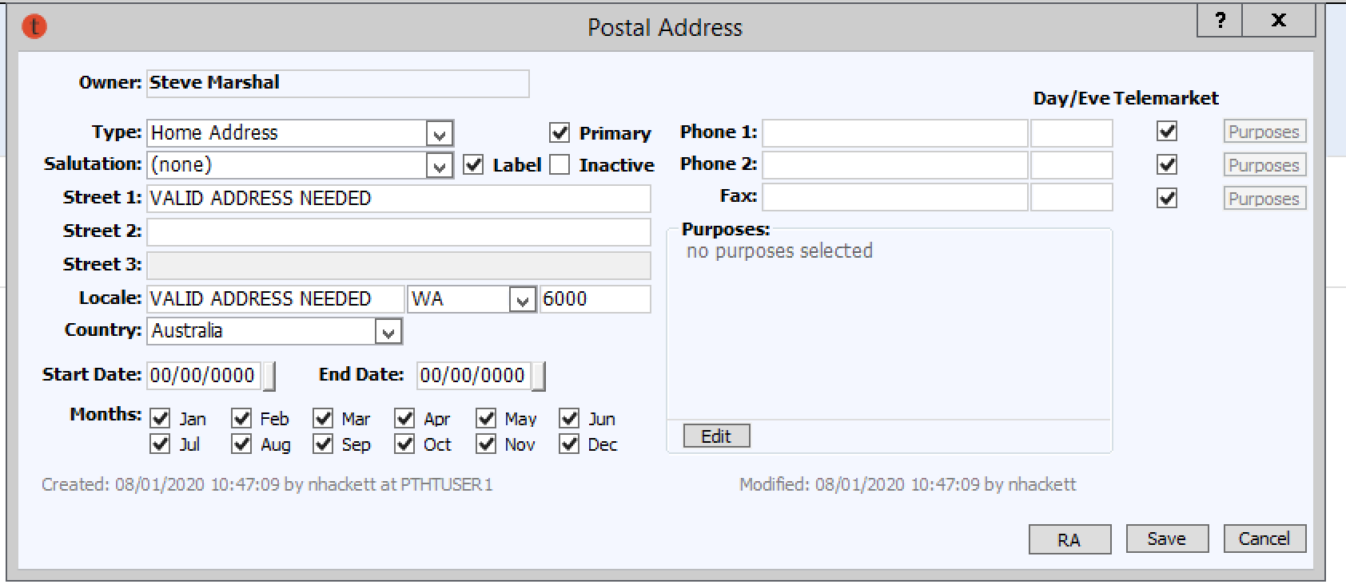

- Then, once, or if there are multiple addresses listed, double click on the address for which mail got returned. A “Postal Address” pop up window will appear.

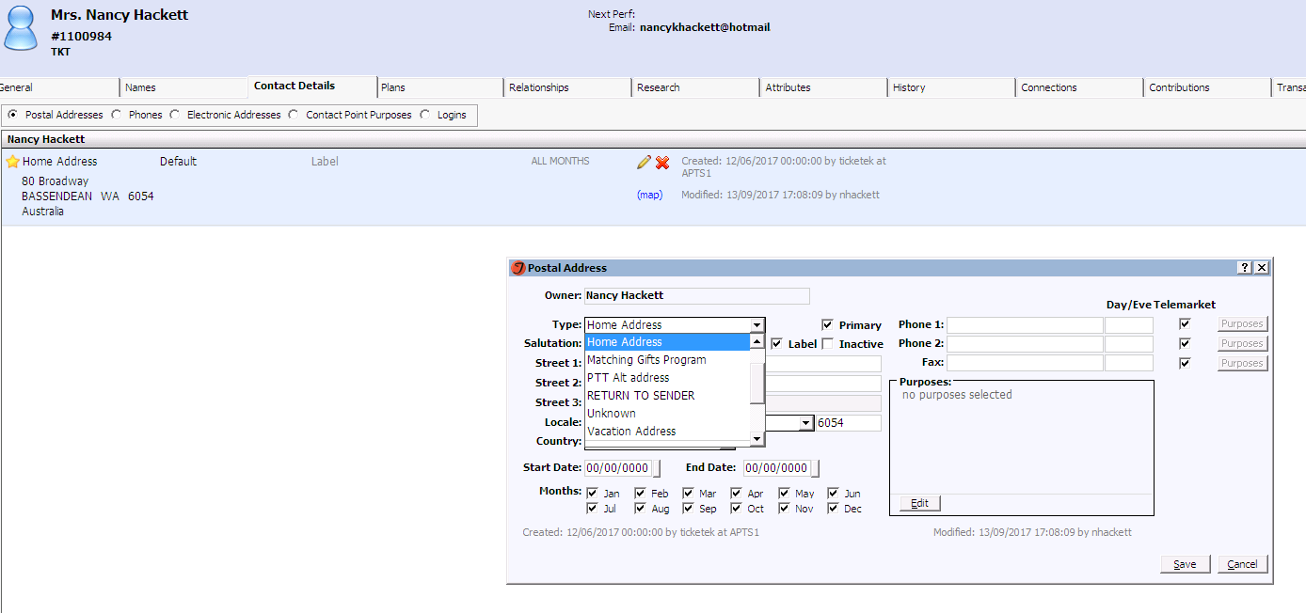
- Change the “Type” from “Home Address” to “RETURN TO SENDER”, untick “Primary” and “Label”, but tick “Inactive” instead and save.
- There is no need to change any other formatting or address details at this stage.
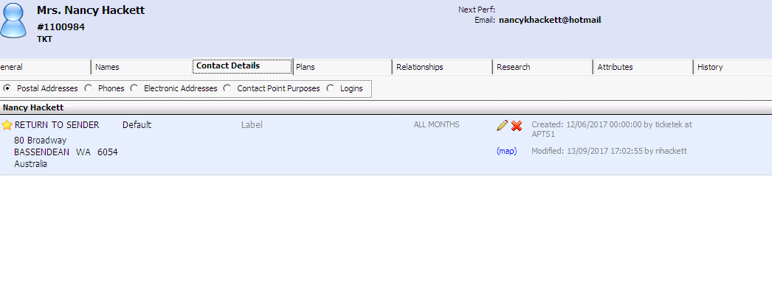
The address will now be marked as “RETURN TO SENDER” in the Contacts Details tab. This (and only this) will be control grouped to be visible across all consortium members.
We recommend the same process is followed by all consortium companies for other, control grouped addresses that are only accessible to individual companies. The inactive RTS addresses will look like this on the Contact Details tab:
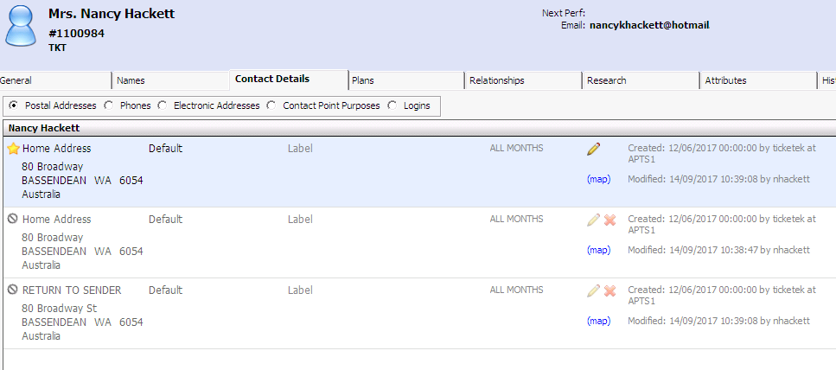

Important Notes:
Ticketing
- On the General tab, there is no immediate visual cue in regards to the RTS status. As part of box office sales scripts/procedures, all box office staff need to ensure that they repeat back the address on the General tab to the customer before completing a sale, and update it if needed using the Contacts Details tab.
- If a new and correct address is received for the constituent in the future, this new address should be added as a “Home Address” type in the Contact Details tab. The RTS address should remain on the Constituent record as a historical record.
Marketing
- To avoid including RTS addresses in lists and extractions, the standard suppression template (still to be created), will include RTS address types (by including a suppression line for this particular info category/address type criteria).
- As long as marketing staff ensure any lists or extractions include the relevant RTS suppression line, any RTS constituents will not be included in postal mailings.

Privacy “opt-out”
Each organisation is responsible for adding and/or removing their own control-grouped mail restriction attributes as appropriate.

Do Not Mail
If it transpires that an envelope that was marked RTS was actually intended as a request to remove an otherwise valid address from mailing lists, then the RTS Address Type should be reverted back to “Home Address” and the organisation-specific mailing restriction Attribute should be applied in its place.

Returned Email (‘hard bounce’)
The Email address type “Hard Bounce” is applied to any email address of the type “Email” that was used for a mail-out via an integrated email system and “bounced” (ie returned as an invalid or expired address).

If an operator is able to ascertain a new address or correction on the address the record should be updated and the type changed back to “Email”.

Organisation Data Entry

To create an organisation constituent record, select the organization constituent type. A new constituent record opens to the General tab. Fill in name and address fields as required following the standard addressing format.

Constituent Type: Organisation
- Always enter the full Company Name in Title Case
- If the Organisation is commonly known by another name or abbreviation (eg ‘NAB’ for National Australia Bank) enter as a non-control grouped “Alias” on the organisation’s record (Names Tab)
- Always enter the Street Address (not a PO Box). Follow the general data entry rules.
- ‘Mailing Addresses’ such as PO Boxes should be attached as a control grouped Address on the “Address” Tab by each consortium partner, dependent on their business rules.
- Organisation records should not have mobile phone numbers on the General Tab. Staff member’s mobile phone numbers should only be on the affiliated Staff Member’s record.
- Never add staff members to the address information on the General Tab. Staff members should be ‘affiliated’ via a control-grouped ‘Affiliation’. This is recommended as a ‘hard’ affiliation (ie affiliated to the staff member’s own constituent record) but can be a ‘soft’ affiliation where staff member’s complete details are not known.
- On Ticket Orders a staff member’s name can be added as the person collecting tickets using the “Order Recipient” field.

Holding Corporate Information on Individual Accounts

There are two scenarios in which corporate information may need to be stored:

- Constituent has a relationship with Perth Tessitura Consortium members because of their place of employment (eg sponsor, government, media contacts).

- Person has an individual relationship with a Perth Tessitura Consortium member, but for general purposes (for example ticket mailing) has provided Business contact details.

Scenario 1:

Relationship Based on Constituent’s Place of Employment

- Establish Individual account
- If available, home address details are to be recorded on General Tab
- Account affiliated to Organisation account using a control-grouped Affiliation type
- Control-grouped Business Salutation added to individual’s Name tab
- Control-grouped Business Address added to individual’s Address tab. “Mail Purpose” settings may also be established at this point dependent on your organisation’s rules.
- Business address updated with related Business salutation type.
- An Alias reflecting the affiliated Organisation name will also be automatically applied to the Constituent to assist with searching on the Organisation name.
  - It is proposed that if the Organisation record itself has an Alias, that this Alias should also be copied to the Constituent.
  - To assist operators this Alias could also be displayed in Constituent Header.

- Where an Organisation has more than one address, head office address will be stored on General Tab and other addresses to be control-grouped on the Organisation’s Addresses tab.

Scenario 2:

Constituent has an Individual Relationship with a Perth Tessitura Consortium Member but has Provided Business Address Details

In this scenario it is NOT necessary to have operators establish a corporate Affiliation to the Constituent’s employer.

Instead, corporate information is to be stored on a non control-grouped Business Address, with associated Business Salutation. This address will then be accessible from the Alt Address option in Ticket Orders to all Consortium members, for the purposes of general business (eg ticket mailings).

In principle the General Tab address should be a home address. However if only a business address is known the operator should:

- Enter address on General Tab
- Create a non control-grouped “Business” salutation.
  - Go to Names tab and add a ‘Business’ type salutation
  - Enter Company Name in the Second Salutation line, and Business Title in the title line
  - If the individual has provided business details for all correspondence, this salutation can be designated as the primary salutation. Department administrators may then choose to create control grouped versions of this Salutation.
- Create a shared “Business” address
  - Go to Names tab and change address type to “Business Address”
  - Select “Business” salutation type for that address

To change details from Business to Home on General Tab
If the constituent subsequently provides home address details the Business Address should be retained in a non-control grouped ‘Business Address’ on the Addresses tab. To create this the operator must:

- Go to the Names tab. Change existing Salutation type to “Business”.
- Create a new Salutation of type “Home” and make this the Default.
- Go to the Address tab. Change existing business address to Address type and Salutation Type “Business”.
- Create a new Address of type “Home” and make this the Default. Also change Salutation Type to “Home”

This can be done by over-typing the existing Business address and answering Yes to the prompt “Do you want to save a copy …”.

NB The saved copy is by default “Inactive”. The operator will need to reload the Constituent and reactivate the record if it is intended to still be available for general purposes. “Mail Purpose” settings may also be established at this point dependent on your organisation’s rules.

Handling changes and removal of Organisational Contacts
When Organisational Contacts cease being affiliated with or change Organisation Department, the following process should be followed:

- NEVER change the A1 to the new position holder. Create a new record for the incoming Organisational Contact.
- Inactivate the Employment Affiliation. Enter in the Notes field the date that this Individual ceased being affiliated with the Organisation Department.
- Remove the Job Title from the General Tab.
- On the Names tab, change the Salutation type to Standard. If a Standard Salutation already exists, delete the Business Salutation and make the Standard Salutation the default.
- If a private non Control Grouped Address is available, make this primary address and inactivate the address relating to the Organisation Department. If a private address is not available, add the “No mailings” restriction. This will be removed when the record is updated with a private address
- Expire/Inactivate the relevant Constituency by an end date.

Schools Data Entry

NB: Generally there should already be a record for every major educational institution in WA on the database. Details on the General Tab of a schools constituent should never be changed, except in the rare circumstance where the school’s street address, name or general phone number changes.

Constituent Type: Education
- Always enter the full School Name in Title Case
- If the School is commonly known by another name or abbreviation (eg ‘PLC’) enter as a non-control grouped “Alias” on the school’s record (Names Tab)
- Hot Tip: Alternate spellings are quite common for school names – please be proactive in adding aliases if you are aware this could be an issue (e.g. St Mary’s/Saint Mary’s/St Marys/Saint Marys or WAAPA/Western Australian Academy of Performing Arts)!
- Where the full school name is too long to fit (most commonly Secondary College campuses) the word “Campus” can be omitted.
- Always enter the Street Address (not a PO Box). Follow the general data entry rules.
- ‘Mailing Addresses’ such as PO Boxes should be attached as a control grouped Address on the “Address” Tab by each consortium partner, dependent on their business rules.
- Schools records should not have mobile phone numbers on the General Tab, unless the mobile is a generic school mobile associated with the school’s administration office. Teacher’s phone numbers should only be on the associated Teacher’s record.
- Never add teachers to the address information on the General Tab. Teachers should be ‘affiliated’ via a control-grouped ‘Affiliation’. This is recommended as a ‘hard’ affiliation (ie affiliated to the teacher’s own constituent record) but can be a ‘soft’ affiliation where teacher’s complete details are not known.
- On Ticket Orders a staff member’s name can be added as the person collecting tickets using the “Order Recipient” field.

Government Contact Data Entry

Guiding Principle: to limit the amount of duplicate records for Government Contacts, Departments and Organisations, and to establish working guidelines for data entry that is used across the Consortium.

Government Contacts

General Tab
- Constituent Type: Individual
- Names: Enter name with correct prefix and suffix. Partners are to be associated (not attached as a secondary name).
- Address: Job Title to contain Electorate Title e.g. Member for Perth.
- Address stored on General Tab is Parliamentary Address. Parliament House to be entered in Optional Address and PO Box in Street Address.
- Enter correct Salutation e.g. Minister. Do not use the Generate Salutation button.
- Phone Numbers: Fixed Line 1 - Phone number relating to the address on the General Tab; Fax - Fax number relating to the address on the General Tab; Mobile - Mobile numbers can be recorded as either Consortium or Control Grouped mobile phone numbers types in the additional phone numbers section.

Names Tab
- General Tab Salutation to be Parliamentary Salutation. Add a salutation type of Ministerial. In the Job Title of this salutation add the ‘Minister for….’
- Add a salutation type of Electoral. . In the Job Title of this salutation add the ‘Member for….’
- Enter any Alias that may be required to make this record searchable. For example an MP may be referred to by the media differently than how they are listed on a parliamentary website.

NOTE: Ministerial Titles that exceed the 55 character limit of the Job Title field should be entered on the Research Tab, as a Title note type.

A truncated Job Title is to be entered in the Job Title field with a prefix of **. This ** prefix indicates to users that full job title can be found in Notes, and allows for easy identification in outputs indicating that manual action is required.

You can retrieve the Title note along with other required data via Output Set Builder. The Title note element is in the Constituent Folder.

Addresses Tab
- The Primary Address should be the Parliamentary Address type. Ensure the Salutation associated with this address in the Parliamentary type.
- Add a Ministerial Address type for the Ministerial Offices e.g. Dumas House, 2 Havelock St WEST PERTH for West Australian Ministers. Link this address with the Ministerial Salutation.
- Add an Electoral Address type for the Electoral street address. Link this address with Electoral Salutation.
- The Government mail purpose flag can be added to your organisations relevant Control Grouped address.

Attributes Tab
Depending on the level of Government the following Constituencies should be applied:
- Federal Gov Department
- State Gov Department

Once the Constituency is no longer valid an end date is to be added which will inactive it. Do not delete these Constituencies.

Relationships Tab
- Government Contacts should be affiliated with the relevant Government Department record using the Government affiliation type.
- Spouse Associations can also be added here, as they are not to be stored in the secondary name field, on the General Tab.
- Full Job title is added in the Notes Field

Research Tab
Public knowledge information can be stored in this tab such as:
- For any changes in portfolio’s, information is to be added to the Research Tab, Notes radio button as a Government note type
- On the Documents radio button, Electoral Maps

Handling changes and removal of Government Contacts
When Government Contacts cease being affiliated with or change Government Department, the following process should be followed:

- NEVER change the A1 to the new position holder. Create a new record for the incoming Government Contact.
- Inactivate the Government Affiliation. Enter in the Notes field the date that this Individual ceased being affiliated with the Government Department.
- Remove the Job Title from the General Tab.
- If a private non Control Grouped Address is available, make this primary address and inactivate the address relating to the Government Department. If a private address is not available, add the “No mailings” restriction. This will be removed when the record is updated with a private address
- Expire/I\inactivate the relevant Constituency by an end date

Government Departments

General Tab
- Constituent Type: Organisation
- Names: Name entered in name field.
- Salutation: Sir/Madam
- Address: Address stored on General Tab is the Parliamentary Address. Parliament House to be entered in Optional Address and PO Box in Street Address.
- Phone Numbers: Fixed Line 1 - Phone number relating to the address on the General Tab; Fax - Fax number relating to the address on the General Tab; Mobile - should not be stored on the Government Department record.

Addresses Tab
- The Primary Address should be the Parliamentary Address type.
- Add a Ministerial Address type for the Ministerial Offices eg Dumas House, 2 Havelock St WEST Perth for West Australian Ministers.
- Add an Electoral Address type for the Electoral street address.

Attributes Tab
Depending on the level of Government the following Constituencies should be applied:
- Federal Government
- State Government
- Once the Constituency is no longer valid an end date is to be added which will inactive it. Do not delete these Constituencies.

Relationships Tab
Government Departments should be affiliated with the relevant Government Contacts record using the Government affiliation type.

Research Tab
Public knowledge information can be stored in this tab such as:
- For any changes relating to this Government Organisation, information is to be added to the Research Tab, Notes radio button as a Government note type.
- On the Documents radio button, Electoral Maps if applicable.

Government Organisations

General Tab
- Constituent Type: Organisation
- Names: Name entered in name field.
- Salutation: Sir/Madam
- Address: Address stored on General Tab is Business Address. This should be the street address of the organisation.
- Phone Numbers: Fixed Line 1 - Phone number relating to the address on the General Tab; Fax - Fax number relating to the address on the General Tab; Mobile - should not be stored on the Government Organisation record.

Attributes Tab
Depending on the level of Government the following Constituencies should be applied:
- Federal Government
- State Government
- Once the Constituency is no longer valid an end date is to be added which will inactive it. Do not delete these Constituencies.

Relationships Tab
Government Organisations should be affiliated with the relevant Government Contacts record using the Government affiliation type.

Handling changes of Government Departments or Organisations
When a Government Department changes its name, or ceases to exist, the following process should be followed:

- NEVER change the name field to the new Government Department. Staff affiliated with this record may not necessarily be part of the new Government Department.
- Inactivate all Government Affiliations. Enter in the Notes field the date that this Government Department changed.
- Expire/Inactivate the relevant Constituency by an end date
- Send a request to the Ticketing & CRM Systems Manager to inactivate the record

Media Organisation Data Entry

To create an organisation constituent record, select the organization constituent type. A new constituent record opens to the General tab. Fill in name and address fields as required following the standard addressing format.

Constituent Type: Organisation
- Always enter the full Company Name in Title Case
- If the Media Organisation is commonly known by another name or abbreviation (eg ‘The West’ for The West Australian Newspaper) enter as a non-control grouped “Alias” on the organisation’s record (Names Tab)
- Always enter the Street Address (not a PO Box). Follow the general data entry rules.
- ‘Mailing Addresses’ such as PO Boxes should be attached as a control grouped Address on the “Address” Tab by each consortium partner, dependent on their business rules.
- Media Organisation records should not have mobile phone numbers on the General Tab. Journalists/staff member’s mobile phone numbers should only be on the affiliated Staff Member’s record.
- Never add journalists/staff members to the address information on the General Tab. Journalists/staff members should be ‘affiliated’ via a control-grouped ‘Affiliation’. This is recommended as a ‘hard’ affiliation (ie affiliated to the staff member’s own constituent record) but can be a ‘soft’ affiliation where staff member’s complete details are not known.
- On Ticket Orders a staff member’s name can be added as the person collecting tickets using the “Order Recipient” field.

Managing Duplicates
The disposition of duplicate constituent records in Tessitura is managed on an ongoing basis through the following steps:

- Potential duplicates are identified via a back-end SQL procedure and are posted to the Merge Constituents screen in Tessitura.
- Designated consortium users review the Merge Constituents screen and schedule duplicate accounts to be merged. Constituents can also be manually scheduled for merges using the Merge Constituents screen, as duplicates are identified during the course of regular business operations.
- Designated consortium users review the scheduled merges and make necessary corrections before the merge is processed.
- When merges have been scheduled and reviewed, a SQL procedure is run which merges the scheduled accounts together.
- Review merged accounts to confirm everything looks as expected.

Deceased Customers

- This deals with the situations where an existing constituent record (individual and/or Household) needs to be re-configured because an individual has died.
- There are specific actions that need to be taken, and specific values that need to be set.

Information about the death of a constituent is received by a user in any consortium member organisation. This user should take the following steps:

- Tidy any details that need to be tidied up (current orders, whatever)
- Change the relevant Status field to ‘Deceased’
- Add an attribute on the constituent’s record - Type: Date of Death. The Value should be the actual date of death, if known, otherwise the date of the notification

If the constituent is a Household member:
- Make them the A2 member (if they are currently the A1 Member, and there is an A2 Member). Use Household Operations\Swap A1/A2)
- Edit their Adult Member Affiliation: Give it an end date, mark it as non-primary
- Add a new Deceased Household Member Affiliation and mark it as non-primary

Then, create a CSI on the constituent’s record
- Category: Constituent Notifications
- Activity Type: Deceased
- Notes – details of the notification

This will alert the Ticketing & CRM Systems Manager to start his actions. He will add Reminders to the CSI to alert any other organisations with touch on the record.

If users from other organisations need to have an ongoing involvement (e.g. in the case of bequests), those users should then create a new constituent:

- Type: Estate
- Name: Estate of Customer Name (or whatever the legal name of the estate is)
- Add a new Deceased Individual Affiliation to the individual record
- Mark it as non-primary

Otherwise, other organisations should:

- Tidy any data on the record
- Mark their Actions complete

The Ticketing & CRM Systems Manager then inactivates the record.

Splitting Household Records after Divorce or Separation

- This deals with the situations where an existing constituent record (individual and/or Household) needs to be re-configured because a household has broken up.
- There are specific actions that need to be taken, and specific values that need to be set.

Information about the divorce or separation of a household is received by a user in any consortium member organisation. This user should take the following steps:

If either member has no contact details of their own (ie only ones inherited from the Household)
- Duplicate the Household address onto that member/s
- Move/copy any known phones or emails from the Household to the individuals
- Migrate any other identifiable pieces of data from the Household to the individuals
- Change the Status field to ‘Separated’ or ‘Divorced’ on the Household record
- Edit each Adult Member Affiliation - give it an end date, mark it as non-primary

Then, create a CSI on the Household record
- Category: Constituent Notifications
- Activity Type: Separated
- Notes – details of the notification

Create another CSI on the Household record
- Category: Constituent Notifications
- Activity Type: Inactivate
- Notes – reason for request

The Ticketing & CRM Systems Manager then adds Reminders to the CSI to alert any other organisations with touch on the Individual or Household records.

Other organisations need to:
- Tidy any data on the record
- Mark their Actions complete

The Ticketing & CRM Systems Manager then inactivates the Household record.

Request for Removal from the Database

If a customer has requested to be “removed from the database”, first ascertain from the customer what they actually want. To facilitate future bookings you can suggest that they retain a customer record, but that the details can be amended to cover any or all of the following scenarios:

- Disable further contacts from your organisation (eg mail/email marketing material, tele-marketing or other activities as relevant)

Action:
If the customer wishes to stop receiving correspondence from just your organisation add your organisation’s relevant “do not contact” flags.

- Customer is moving overseas/’away”

Action:
Where possible rather than permanently removing the record instead, add the relevant Mail, Phone and E-Market restrictions (e.g. “No Mailings”, “No Telemarketing”, “No E-Marketing”). This allows us to retain useful individual marketing information, and also allows the record to be ‘reactivated’ if the customer returns at some other time.

- Remove Credit Card information from the record

Action:
Credit card numbers cannot be removed from a Constituent record. Advise the customer that this information is required to be retained to maintain transaction and payment history, but that the details are “masked” in accordance with PCI (Payment Card Industry) compliance regulations.

If they still insist on this information being removed then the only option is to permanently delete the entire record. See scenario 4.

- Permanently delete their record

This disables further contacts from any of the seven Perth Tessitura Consortium organisations with which they may have had contact.

Action:
If they insist on being permanently removed from ‘your’ database the customer needs to be advised of the other Perth Tessitura Consortium organisations that share the database. At this point they may choose to just disable contact from your organisation (e.g. they are a subscriber with one of the other companies). See scenario 1.

Once they have been made aware that deleting their record will affect all Perth Tessitura Consortium organisations and they still want to proceed please send details of the request with the customer’s name and Constituent ID(s) to the Ticketing & CRM Systems Manager via the Perth Tessitura Consortium Support Portal .

All organisations with data on the record(s) will be notified and then the record will be removed by merging into the ‘Perth Tessitura Consortium Remove from Database’ record, and name/contact data deleted.

Member Organisation Responsibilities
Each member organisation is responsible for scheduling and reviewing merges. Tessitura best-practice recommends users from both development and box office functions be involved in the data review process. For example, prior to the running of a merge procedure the box office can be the department that schedules all merges, while the development or marketing department is charged with reviewing and approving all merges.

Member organisations should carefully compare the following data points when reviewing constituent records for potential duplicates:

- Account creation dates
- Constituent names, addresses, and other contact details
- Account information

As a general rule, keep a Consortium record rather than a Perth Festival record (due to the Consoritum’s data quality with QAS data entry) when determining which of multiple constituent records to keep, always keep the record with the lowest constituent ID number. More tips on scheduling merges can be found here.

Do not merge:
- Records where the first names do not match AND other items of account information do not match
  - E.g. John Smith and Jack Smith have the same address, phone number, and email address = Verify that Jack is an alias for John prior to scheduling the merge
  - Jane Doe and Jeanne Doe have the same address, but different phone numbers and different email addresses = DO NOT MERGE without further research
- If further research indicates that Jane and Jeanne are the same person, make appropriate changes in the accounts, document them clearly with a CSI, and proceed with the merge.

When in doubt, do not merge. Undoing a merge is nearly impossible.

Organisation Prefix or Suffix Codes

These codes must always be applied to data elements where appropriate, either as a Suffix or Prefix, dependent on rules for each element. When used as a Prefix these codes should not be entered inside parentheses or other brackets.

Perth Theatre Trust PTT
Barking Gecko Theatre Company BGTC
Black Swan State Theatre Company BSSTC
Co3 Australia CO3
Perth Festival PF
West Australian Ballet WAB
West Australian Opera WAO
Yirra Yaakin Theatre Company YYT
*ALL (Default Control Group)

*Indicates the data is not control grouped and is accessible to all Users

- Certain control-grouped elements that appear in a dropdown (eg Payment Types) should have a SUFFIX applied.
- Other control-grouped elements (eg Attributes) should have a PREFIX applied, principally for ease of use in Extractions.
- Elements where control-groups are not considered (eg Price Types) should have a PREFIX applied.
- Control Groups must always have an organisation PREFIX. Exception: Where a Control Group has been established specifically to control access to a particular data element then the name should reflect that access.

Facility Manager - Formatting Conventions

Please note the following formatting conventions are currently still evolving and conventions may change during the implementation phase.

Zone Maps / Zone Description
These rules recommended for all Facilities, and required for any event in PTT venues.
NB: The “Abbrev” field is a core requirement for the sorting of “reserves” in reports such as Net Sales Report, Performance Statement report etc.

- Description:
Section <ALPHA> ‘Reserve’
Eg: Stalls A Reserve
Stalls B Reserve
Stalls C Reserve Restricted View
Exception: Premium should not include the word ‘Reserve’

- Short
Abbreviation of Reserve + abbreviation of section
Eg: Prem
A Res
B Res Rstr
Standing Room to be entered as full word “Standing”
Wheelchair to be entered as “Wheelchr”

- Abbrev
Premium Full word ‘Premium’
Other Reserves <ALPHA> ‘Res’
Eg: A Res
D Res
Standing Room Full word ‘Standing’
Wheelchair Just a Wheelchair Hold type – Hold Code W
Balcony Full word ‘Balcony’

Production, Fee and Season Elements - Formatting Conventions

Title
- Always must have start with a four digit year
- Should be company specific

e.g.
2018 Barking Gecko Theatre Company
2018 Black Swan State Theatre Company
2018 Co3 Australia
2018 PTT Presented
2018 West Australian Ballet
2018 West Australian Opera

Performance Codes
For PTT Production Seasons the code is structured to allow for date sort within Production – the format is: 3 digits for Performance/ResCo – YYMMDD – Additional unique identifier code

E = Early
M = Matinee
A = Afternoon
L = Late
H = Heath Ledger
S = Studio Underground

ResCos:

PBS = Performance Black Swan
PWB = Performance WA Ballet
PWO = Performance WA Opera

PBS180612H = Black Swan 12th June 2018 Heath Ledger performance
PBS180612S = Black Swan 12th June 2018 Studio Underground performance

Due to cross over performances in STCWA evening Black Swan performances need to have the venue code at the end

PBS180612E = Black Swan 12th June 2018 morning performance

PWB181012M = WA Ballet 12th October 2018 Matinee

PWO181124 – WA Opera 24th November 2018 performance

Commercial Hirers

PHL = Heath Ledger Theatre
PSU = Studio Underground
PPR = Princess Royal Theatre (Albany Entertainment Centre)
PHM = His Majesty’s Theatre
PDM = Downstairs at the Maj

e.g.:
PHL181012L = Heath Ledger Theatre 12th October 2018 Late performance

Fees
- Always must have an organisation PREFIX
- Inactive Fees should be renamed with a “ZZ” prefix followed by the original fee name

eg:
BSSTC Handling Fee (Phone)

Registered post and web handling fees can’t use a prefix due to them appearing on TNEW and having no web alias. Therefore:

Black Swan Registered Post = Registered Post

GL Descriptions
- Always must have an organisation PREFIX (tbc)

Batch Types
- Always must have an organisation PREFIX (tbc)

Payment Method
- Always must have an organisation PREFIX
Eg: BSSTC – Credit Card AMEX
WAB – Master CC

Seasons
- Defined in TR_SEASON
- Always must have a year and organisation PREFIX

e.g.
2018 BSSTC Commercial = Black Swan 2018 Season
2018 WAB Commercial = West Australian Ballet 2018 Season
2018 WAO Commercial = West Australian Opera 2018 Season

Price Types
- Defined in TR_PRICE_TYPE
- Always must have an organisation PREFIX

e.g.
BSSTC - Adult = Black Swan Adult Ticket
BSSTC – Subs – Student = Black Swan Subscription Student Ticket
WAB - Adult = WA Ballet Adult Ticket
WAO - Concession = WA Ballet Concession Ticket
PTT – Junior = PTT Junior Ticket

All RESO sold price types have RESCO prefix at start
All PTT sold price type have PTT

Modes Of Sale
- Defined in CAMPAIGNS/REFERENCES
- Always must have an organisation reference

e.g.
Black Swan Office Subs
Black Swan Phone Singles
Black Swan Web Subs

HMT Sales = PTT His Majesty’s counter & phone sales
HMT QuickSale = 30 mins prior to a performance counter sales

Hold Codes
- Always must have an organisation PREFIX

e.g.
BSSTC – Promoter Hold
WAB – Promoter Hold

Packages
- Each organisation to define local naming conventions for package codes

Package names appear on TNEW and there’s no alias so can’t have organisation prefix (e.g. BSSTC) at the beginning. ResCos define naming within the character limit, eg:

4-Play Combo (BSSTC 4 Play Combo)
Festival 2PAC – Boys (BSSTC 2 play package The Boys Are Back in Town)

Ticket Design
- Always must have an organisation PREFIX

e.g.
BSSTC Standard Reserved Ticket

Lists, Extractions, Reports etc – Naming Conventions

Extractions
- Naming conventions to be established

Queries
- Naming conventions to be established

Lists
- Naming conventions to be established

Reports
- Naming conventions to be established

Ticket Printing Batches
- Always must have an organisation PREFIX

Attributes
- Defined in T_KEYWORD
- Shared (non-control grouped) attributes to have the ALL PREFIX applied
- Control-grouped attributes to have an organisation-specific PREFIX applied

Campaigns
- Always must have an organisation SUFFIX

Funds
- Always must have an organisation PREFIX

Source Codes
- Always must have an organisation PREFIX

Associations
- Defined in TR_XREF_TYPE
- Always must have an organisation PREFIX

Customer Service Incidents – Formatting Conventions

Category
- All Categories are shared across the Consortium.
- Must always be generic (without organisation PREFIX or SUFFIX). Any proposal for new Categories to be communicated to Ticketing & CRM Systems Manager.

Activity
- Linked to generic Categories through TR_CUST_ACTIVITY_TYPE
- Always must have an organisation PREFIX

Resources and References

Tessitura Help Documentation v12.5.1 – Full Table of Contents

Consortium Reference Library - to be created (accessible to all)

Common Flat/Unit Types

Apartment
Cottage
Duplex
Factory
Flat
House
Kiosk
Maisonette
Marine Berth
Office
Penthouse
Rear
Room
Shed
Shop
Site
Stall
Studio
Suite
Townhouse
Unit
Villa
Ward
Warehouse

Floor/Level Types

Basement
Floor
Ground Floor
Level
Lower Ground Floor
Mezzanine
Upper Ground Floor

Postal Delivery Type Abbreviations

Postal Delivery Type | Abbreviation | Postal Delivery Type | Abbreviation
Care Of Post Office | Care PO | Poste Restante | Care PO
Community Mail Agent | CMA | Private Mail Bag Service | Private Bag
Community Mail Bag | CMB | Roadside Delivery | RSD
General Post Office Box | GPO BoX | Roadside Mail Bag | RMB
Locked Mail Bag Service | Locked Bag | Roadside Mail Box | RMB
Mail Service | MS | Roadside Mail Service | RMS
Post Office Box | PO Box | Community Postal Agent | CPA

Perth Tessitura Consortium Support Portal Information

Apart from consortium support please note the resources that are available to all consortium companies:

- Self-help (e.g. users can reset Citrix password themselves)
- Super users in each organisation
- Tessituranetwork.com documentation, forums and other learning resources
- For TNEW queries – support directly from Tessitura Network
- Direct support from Tessitura Network for application related queries

Consortium Support Portal:

Barking Gecko Theatre Company:
Support Portal: https://barkinggecko.on.spiceworks.com/portal/
Support Email: tessitura@barkinggecko.com.au

Black Swan State Theatre Company
Support Portal: https://bsstc.on.spiceworks.com/portal/
Support Email: tessitura@bsstc.com.au

Co3 Australia
Support Portal: https://co3.on.spiceworks.com/portal/
Support Email: tessitura@co3.org.au
Perth Festival
Support Portal: https://perthfestival.on.spiceworks.com/portal/
Support Email: tessitura@perthfestival.com.au

Perth Theatre Trust
Support Portal: https://ptt.on.spiceworks.com/portal/
Support Email: tessitura@ptt.wa.gov.au

West Australian Ballet
Support Portal: https://waballet.on.spiceworks.com/portal/
Support Email: tessitura@waballet.com.au

West Australian Opera
Support Portal: https://waopera.on.spiceworks.com/portal/
Support Email: tessitura@waopera.asn.au

Yirra Yaakin Theatre Company
Support Portal: https://yirrayaakin.on.spiceworks.com/portal/
Support Email: tessitura@yirrayaakin.com.au

Support Telephone: +61 8 9265 0959
Support Telephone Hours: 09:00 – 17:00, Monday – Friday

