Plans SOP

To create a plan, there needs to be:
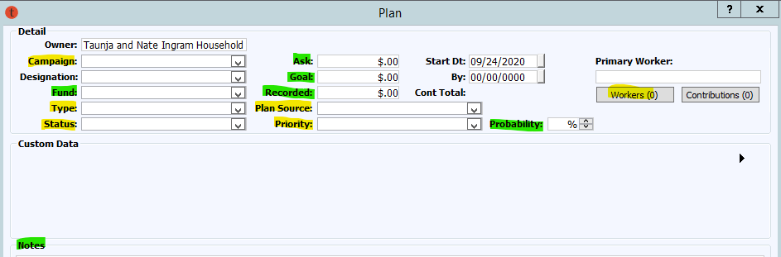
- A Campaign
- A Type
- A Status
- A Plan Source
- A Priority
- A Worker
- Optional:
  - Fund
  - Ask
  - Goal
  - Recorded
  - Probability
  - Notes – though this is optional a basic idea of what you are going for with the plan is helpful (i.e. Working on a gift for Early Education, 18-24 month cultivation for a major gift, or relationship cultivation for a campaign gift in the next couple fiscal years).

Campaign Plans on Records: Every Plan must have a Campaign.
- Each plan campaign connotes the type of relationship we have with the donor (And the furthering of that relationship)
  - Relationship: PHL are for the cultivation relationship life of the prospect/donor (if you are sending a proposal, please set up a FYXX Station/Foundation and make sure the Ask and Recorded sections are filled out).
  - Board Service are plans used for steps used in the relationship of BOT and FDN Board members.
  - FYX Foundation are for bringing proposal gifts to the Foundation for a specific fiscal year.
  - FYX Grants are for bringing in proposal grants during the specific fiscal year
  - FYX Corporate Gifts Rev are for bringing in proposal project or facilities funding during the specific fiscal year
  - FYX Station are for bringing in proposal gifts during the specific fiscal year that do not go through the Foundation
  - FYX Station/Foundation with Planned Gift as the Fund are for estate gifts
  - Legacy Society Plans are for stewardship of our Legacy Society Donors
  - Prospects: Grants are for Grantors who haven’t been solicited yet, but connections are being made before we know we’re going to ask them for money.
  - Prospects: Planned Giving are for building plans for deferred gifts or more complicated planned gifts.
  - Prospects: Philanthropic Gifts are for non-donors who we are working on at the moment, who may or may not become a relationship plan.
  - Stewardship: Philanthropic are for Stewardship activities if the person is not in an active cultivation state at the moment
  - Perpetual Trusts Plans are for gifts that are tied to a perpetual trust
  - Comp Campaign are plans set up for prospect/donors directed by BrightDot for the Comprehensive Campaign
  - TA Conversion Philanthropic Gifts house all the interactions from Major Gifts before the conversion to TA. Please do not alter this in any way-it is historical data for our records
  - CC Plans are for early Comprehensive Campaign Activities. They include
    - SAC – study advisory committee activities
    - Campaign Interviewee – follow up to interview information
    - Campaign Aspirational – relationship building with people who don’t really have a connection with us but that we want to have one.
- Campaign changes can happen for a variety of reasons
  - A Legacy Society Plan changes to a FYX Planned Giving Plan because the donor dies
  - A FY24 Station plan changes to a FY24 Foundation plan because the way the donor is sending in the gift changes
  - A FY23 Station plan becomes a FY24 Station plan because the ask wasn’t made until FY24
  - A Prospect: Planned Giving Plan changes to a Legacy Society Plan because the donor documents a gift.
- When you need a new campaign?
  - When all the gifts are in for that FY; the plan has been completed; and you are submitting a new proposal for the current fiscal year.
  - When the purpose of your cultivation is for a specific reason (see CC: Campaign Interviewee or CC: Study Advisory Committee, Legacy Plan, FYX Planned Giving Plan)

Designation: Designations are for directed funds towards specific projects
- Most of these will be used for Grants and Corporate, and for large philanthropic proposals.
  - I.E. Social Impact, Black Issues Forum, Front Row, Awareness Campaign.
- If you do not see your project, please request it be added by the Philanthropic Gifts Manager.

Funds: There does not need to be a fund decided until you know if the gift is going to a specific focus.
- Currently in FYXX Station, there is a Station Unrestricted Fund and then breakouts for
  - Station Campaign
  - Station Restricted
  - Station Planned Gifts (For Bequest Gifts only)
  - Station Project Funding
- Currently in FYXX Foundation, there is a Foundation Unrestricted Fund and then breakouts for
  - Foundation Campaign
  - Foundation Corporate Gifts
  - Foundation Grants (Only for Grants)
  - Foundation Planned Gifts (only for Bequests)
  - Foundation Restricted
- Currently in FYXX Grants there is a Station Grants Fund and then we breakout projects by Designation.
- Currently in FYXX Corporate Gifts Rev there are four funds
  - Corporate: Project Funding (for specific Projects)
  - Facilities: Rental & Production Services (for specific productions)
  - UW Corporate Partners (for Underwriting)
  - Corporate Partnerships

Plan Type: This is which department is working on the plan:
- Annual Giving – if there is a specific plan for annual giving (may be used for relationships with donors in this area).
- Campaign Giving – if it is specifically for Campaign only gift.
- Corporate Gifts – if it is for a corporate gift
- Grants – if it is for a Grant
- Philanthropic – if it is for a Major Donor, Planned Giving, or other Philanthropic plan

Plan Status:
01 Identification – This status is applied to plan when assigned to a Gift Officer. This status may equally indicate that an account has moved from from another GO’s account.
02 Research – This status is the second level of a donor, indicating that research to determine capacity, interests, and background process, reflecting that the Gift Officer had begun actively working on this account.
03 Qualification Screening – 4x2x3 contact and determine major donor potential
04 Strategize – This status indicates that (1) research identified this donor as stakeholder with connections to UNC-TV through Board members or their stakeholder groups or (2) next step in moving the donor along depends on first strategizing with content experts/creators on the best approach for the donor.
05 Cultivation – This status reflects that the donor is open to communicating with UNC-TV and the gift officer is actively developing an understanding of the donors giving goals and willingness to review a proposal of support on behalf of UNC-TV.
06 – Approaching Ask – This status indicates the Gift Officer is with in the final stretch of preparing a proposal for a donor (a donor should be in this status for 1 week to 3 months)
- GO should complete the Goal section of Tessitura in this step
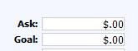
07 Ask/Proposal Submitted – This status indicates that a proposal has been presented to the donor.
- GO should complete the ask section of Tessitura in this step.
- GO should complete the applicable fund to the account if the ask pertains to a specific project.

08 Invoicing – this status reflects invoicing is being sent to the constituent (mostly for Grants/Corporate)

09 Commitmemt Received – This status reflects a verbal or other acceptance of the proposal. Some negotiation may take place during this time period. The donor stays in this status until a signed agreement/comittment form execution/gift received.

10 Contribution In (Cont In/Stewardship) - This status reflects a single gift commitment is in place and gift payment is being collected.

10 Multi-Year Proposal/Stewardship (Multi-Year Ppl/Stew) – this status reflects a multi-year commitment is in place and gift payments are being collected.

11 Patron Decline – This status reflects that a donor declined to move forward with gift. (GO officer completes a step on the plan with details about donor conversation, and recommendations on plan termination/stewardship/cultivation to better understand donors giving interest.)

12 Planned Giving – This status indicates that the GO believe the donor is best cultivated as a planned gift donor and should be moved to the PGO portfolo.

13 Other Priorities – This status means the donor has indicated that they will continue to give at the level at which they are currently supporting and will not give more.
- GO should create a step that indicates ot MPGM that the donor should be moved to: Stewardship (Annual Fund Plan)
Stewardship (Major Gift)

14 Probate – This status indicates that a donor is deceased and PBS North Carolina has received a Notice of Beneficiary (NOB) or they are a member of the Legacy Society with a Planned Giving Commitment form on their account. The account stay in this until all distributions from the estate have been made. Then the plan is completed, and the estate is marked inactive.

15 Plan Terminated – This status indicates the plan associated with this indicator had come to it’s conclusion. The GO should indicate in step the reason for requesting the plan be terminated.
The DPG or PGM will take the final action on the plan. The Philanthropic Gifts Manager or Prospect Manager will terminate the plan and that plan will stay on the record for historic purposes.
- For Planned Gifts—gifts that never came to fruition or were pulled from the donor will be terminated.

16 Plan Completed – This status indicates the plan associated with this indicator had come to it’s conclusion. The GO should request to complete the plan. The DPG or PGM will take the final action on the plan. The Philanthropic Gifts Manager or Prospect Manager will close the plan and that plan will stay on the record for historic purposes.
- For Planned Gifts that were actualized, they will be marked complete.
- For Corporate/Grant gifts that came in per FY, they will be marked complete.
- For FYX Philanthropic Plans that came in, they will be marked complete
- Any relationship plans or stewardship plans that come to an obvious stop point, will be marked completed.

Plan Steps:
Plan Steps are for clarifying steps taken in the process of soliciting gifts or building the relationship. If you build them correctly, they will power your reminders page, and keep your work organized and helpful. To see how to add multiple steps at once, see below.
- Step Type is how you are communicating or what you are trying to accomplish
- Step Description is a little more specific (I.e. Type: Email/Description: Email about ncIMPACT)
- Worker is you or whomever you need help with (the Philanthropic Gifts Manager)
- Step Date is the date you are entering the Step
- Due Date is when you want to accomplish it by (if you do not fill this out, they will not appear on your reminders)
- Completed Date is when you completed the step (Please make sure to fill this out when you have finished the step, or they remain open for those of us pulling steps that haven’t been accomplished)
- Warn Days are how many days warning before the due date you want it to show in your reminders.
- Plan Step Priorities
  - If it a quick blurb of connection, please make it a low priority
  - If it is something that you know you need to do or accomplish, high or medium is good
  - If it is something that the Director of Philanthropic Gifts, Chief Growth Officer, or Philanthropic Gifts Manager Needs to see (contact reports, call reports with important information, etc.), please mark the priority as high.
    - High: Substantive conversations and interactions that move the donor forward in the pipeline, email, phone, etc.
    - Medium: Substantive Emails/Letters that are sent to multiple people,
    - Low: LVM
- Associate ID
  - Associate ID is for other people in on your meeting—Who joined you
    - A Board Member
    - Their Financial Advisor
    - A Sibling or child
    - The head of their foundation
- Attachment
  - Only add attachments if crucial to the step (if they are in our Group Drive, it may be easier to put a note about where they are in notes—rather than save the information in two places.
  - Currently, we are adding Contracts for Corporate and Grants
    - We need to decide if we want to add invoices, or leave them on the R drive
- Notes: this is for
  - The project/initiative associated with the plan (will appear in Plan Notes column on portfolio list if you add it).
  - All Call Notes
  - Copy and Paste your email
  - Make notes after your meeting
  - Send follow up information on a step with another worker to meet with you
  - Anything that will further your step.

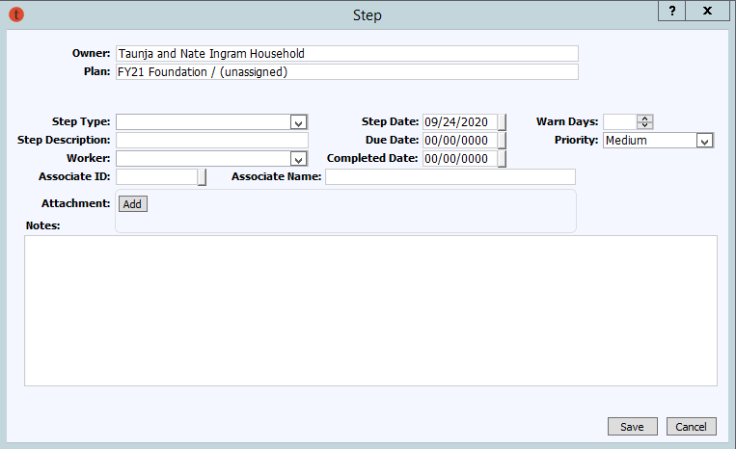
Planned Gifts:
- If you are working on a FYX Plan and your donor mentions that they may have a planned gift for us. Please
  - create a step with the worker being the Philanthropic Gifts Manager or Prospect Manager
  - Put all the information about the gift in the notes for the PGM
  - The PGM will create a new record on the History/Planned Gifts Section of Tessitura
  - If the Gift is documented, the PGM will also create a Legacy Society Plan for Stewardship of the gift, and add the LM constituency to their record

Terminating a plan:
- When you have reached the goal of your plan
  - The purpose of the plan is fulfilled
    - you need to move them to a stewardship plan
    - they have other priorities
    - you have finished any CCS Interviewee tasks
    - you have qualified them, and they aren’t a prospect
  - Please add a step with HIGH priority for the Philanthropic Gifts Manager
    - In the step notes detail what needs to happen next.
  - Please put your final notes regarding the plan on the Plan notes, so anyone looking in can understand why the plan has been terminated.
  - The Philanthropic Gifts Manager or Prospect Manager will terminate the plan and that plan will stay on the record for historic purposes.

Probate Gifts/FYX Planned Giving Plans
- When a donor or member dies and we are alerted to the fact
  - The PGM is notified and an Estate Record is created
    - An Executor or Attorney is added to Relationships (or both)
    - Any contact details are listed on the record
  - The donor is
    - Linked to the Estate Record
    - Marked as Deceased
    - Death Date is entered in Attributes
    - Obit is Saved under Research/Notes
    - Changed to Inactive
  - The PGM creates a FYX Planned Giving Plan, and multiple steps are added:
    - Contacting the Executor or Attorney
    - Asking for the Relevant Will Page
    - Scanning in all relevant Documents
    - Any conversations had with relevant parties
    - Possible Goal put on how much we could expect.

Using your portfolio display
- Last Plan Step: Last step Completed
  - Not as Helpful: Last Step Type: Most recently entered step.
  - Last Step Date: Helpful to see – last plan step only stuff you have had a due date on.
- Next Plan Step: Next step with the closest Due Date
  - Not as Helpful: Next Step Type: The Next Step with the closest due date
  - Not as Helpful: Next Step Date: Start date for the next step
- Plan Notes: The Notes from the Notes Section of your plan
- Constituency String: All the Constituencies on the record
- Ask Amt: The amount the donor will be asked to contribute.
- Goal Amt: The amount expected to be received from the donor.
- Recorded Amt: How much they commit to verbally or via email.
- Contribution Amt: How much has been processed.
- Probability %: The probability that they will say yes (not the % you think they’ll agree to).

