
TNEW Education Registration
Customization

Documentation Version 0.2 - Last Revised: 12/9/2020
Copyright 1999-2019 by Impresario L.L.C.
(as an unpublished work subject to limited distribution and restricted disclosure only).
All Rights Reserved
NOTICES
The material contained in this manual is protected by the copyright laws of the United States of America and by international treaty as an unpublished work. Unauthorized use, reproduction or distribution of the material contained in this manual is punishable by civil and criminal penalty.
This material contains proprietary, confidential, and trade secret information of Impresario L.L.C. and is provided solely for use by licensees of the Tessitura Software ® program and their authorized employees. Except as expressly authorized by Impresario L.L.C. pursuant to the terms of a written license agreement, no part may be used, disclosed, distributed, reproduced, transcribed, stored in a retrieval system, adapted or transmitted in any form by any means, electronic, mechanical, magnetic, optical, chemical, manual or otherwise.
Tessitura Software ® is a registered trademark of Impresario L.L.C.
All brand or product names mentioned in these materials are the trademarks or registered trademarks of their respective companies.
THE MATERIAL CONTAINED IN THIS MANUAL IS FURNISHED “AS IS” WITHOUT WARRANTY OF ANY KIND AND ALL WARRANTIES EXPRESS OR IMPLIED, ARE HEREBY EXCLUDED (INCLUDING, WITHOUT LIMITATION, ANY CONDITIONS OR WARRANTIES RELATING TO MERCHANTABILITY OR FITNESS FOR A PARTICULAR PURPOSE). IMPRESARIO L.L.C. SHALL NOT BE LIABLE FOR ANY TECHNICAL OR EDITORIAL INACCURACIES OR OMISSIONS MADE HEREIN
The material contained in this manual is subject to change without notice. Impresario L.L.C. assumes no obligation to keep customers informed of any inaccuracies, updates, additions, deletions or other changes or modifications to any of the material contained in this manual.
IMPRESARIO L.L.C. SHALL NOT BE LIABLE FOR ANY SPECIAL, INCIDENTAL, INDIRECT OR CONSEQUENTIAL, PUNITIVE OR EXEMPLARY DAMAGES OR FOR LOST PROFIT, REVENUE, USE OR DATA IN CONNECTION WITH THE MATERIAL CONTAINED IN THIS MANUAL, EVEN IF ADVISED OF THE POSSIBILITY OF SUCH LOSS.
Licensees are solely responsible for their use of this manual and the software to which it relates in full compliance with all applicable laws, rules and regulations and Impresario L.L.C. assumes no responsibility for informing licensees of any applicable laws, rules or regulations or any changes thereto that might occur from time to time.
Table of Contents

Overview 1
Online Registration Pages 1
Registration Data in the Constituent Record 2
Processing Orders in Tessitura 4
Configuration 5
Season Configuration 5
Price Type Configuration 5
Keyword Configuration 6
Content Configuration 7
Form Configuration 9
System Tables 11
LTR_TNEWCUSTOM_EDU_AFFILIATION_OPTIONS 11
LTR_TNEWCUSTOM_EDU_PRICETYPE_AFFILIATIONS 11
LTR_TNEWCUSTOM_EDU_GRADES 11
LTR_TNEWCUSTOM_EDU_KW_GRADE 12
LTR_TNEWCUSTOM_EDU_FORM 12
LTR_TNEWCUSTOM_EDU_SECTIONS 12
LTR_TNEWCUSTOM_EDU_QUESTIONS 12
LTR_TNEWCUSTOM_EDU_FORM_QUESTIONS 13
LTR_TNEWCUSTOM_GLOBAL_CONTENT 14
LTR_TNEWCUSTOM_ WEB_DEFAULTS 15
LTR_TNEWCUSTOM_EDU_SCREENS 16
Sample Site Screenshots 17

Overview
The Education Registration customization for Tessitura allows organizations to sell products such as camps and classes online, while also collecting important data about registrants, and adding built-in restrictions for age/grade.

Online Registration Pages
The Education Registration customization adds additional pages into the online purchase/registration path in TN Express Web (TNEW) via a pre-cart customization.
There are two possible purchase paths a customer may encounter:
Customers can either add the applicable event/item or fixed-seat package to the cart first, and trigger the Recipient Page, or begin by adding a Participant and selecting the registration item with that first page:
Custom page TNEW page
Class First Path:
Customer adds the applicable event/item or package to the cart first, triggering display of a custom page to add the recipient.

Participant First Path:
Customer begins on a page that allows adding a participant and selection of the event/item on the same screen.

To view layouts for each of the pages below, see the Sample Site Screenshots section.
Item Detail Page
Used when adding a class on a separate page before adding the participant. The class can be set up as a performance event/item or a fixed-seat package in Tessitura. (see screenshot)
Recipient Page
Used to attach a participant after a class has been added to the cart. (see screenshot)
Participant First Page
Used to add or select a participant first, then add an applicable class within a single page. (see screenshot)
Add-on Page
Used to display and select specific add-ons for classes. If you purchase “X”, you can purchase “Y” (e.g. – bus transportation, extended care, t-shirt, meals, etc.). (see screenshot)
Summary Page
Displays a summary of each class, including costs, participants and add-ons. Allows the customer to add another participant, another class, or continue to checkout. (see screenshot)
Note: You can edit the entry edu_registration_summary_cart_timer in the system table LTR_TNEWCUSTOM_WEB_DEFAULTS to reset the cart timer to a set number of minutes, allowing ample time for the customer to complete checkout.
Form/Waiver Page
Collects additional data about the participant. Forms can be spread over multiple pages. Data entered here is saved when the customer reaches the Payment page. (see screenshot)
Note: You can edit the entry edu_registration_form_cart_timer in the system table LTR_TNEWCUSTOM_WEB_DEFAULTS to reset the cart timer to a set number of minutes, allowing ample time for the customer to complete the form.
Cart Page
Lists all items in the cart, including any non-education registration items. If a customer removes a main registration item from the cart, any related education add-ons will also be removed. (see screenshot)
Note: If an item has been added to the cart and associated people or form questions have not been answered, the customization will catch the error before checkout can proceed and return the customer to the Recipient or Form/Waiver page.

Registration Data in the Constituent Record
All of the registration data collected online is populated into the participant’s constituent record. In addition to participant names and contact information, education registration data is stored within Research Notes, Attributes, and in the Custom tab.

Affiliations
When a new student is added under an existing account login, a household will be created to handle the affiliation. For example, a child-aged registration would result in a household account with an Adult affiliate and one or more Child affiliates. These Affiliation names can be seen in the Relationships tab on the household account.
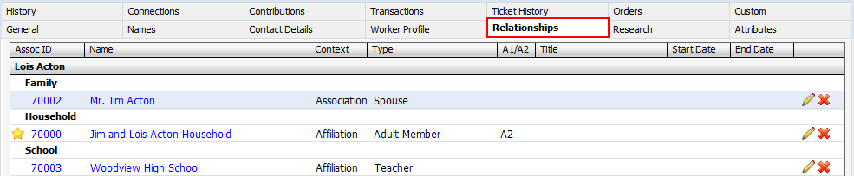

Edu Main Screen
This screen lists all question responses grouped by section. If a customer updates a response to the same question in the future, the data on this screen will be updated.
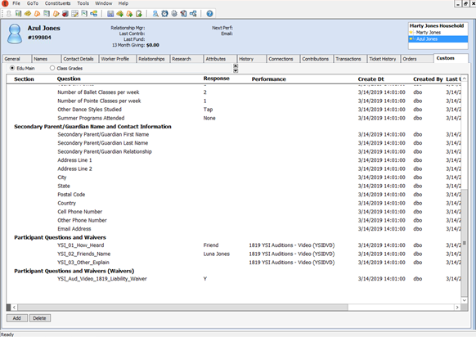
Note: If an online order is abandoned prior to the payment page, form responses will not be saved. If a successful order is cancelled or refunded in the future, data in the custom screen will be preserved.

Class Grades Screen
This screen holds contains a list of registered classes and the applicable grade level of the participant at the time of the class. These are static entries that do not change when the student changes grade levels.
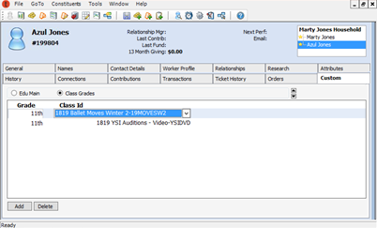

Processing Orders in Tessitura
Registrations by phone or in person can be processed as orders directly in the Tessitura application.
Note: It is important to follow these steps exactly to replicate the data customization process and correctly add recipients and questions to the order.
- Create a new order in Tessitura.
- From the Line Items tab, add the applicable performance(s) and/or fixed-seat package(s).
- In the Sub Line Items tab, add a Recipient to each education class line item.
- Process payment and save the order.
- Open the Edu Main Screen for the Recipient and complete responses for the questions listed. Add an entry to the Class Grades screen (if applicable).
Note: There is no validation in the Tessitura application to prevent registration of a student outside of an age or grade restriction.

Configuration
To set up education offerings and related forms, complete the following configuration steps in the Tessitura application.
- Define which performance or fixed-seat package items will trigger the customization, as well as available pricing.
  - Season Configuration
  - Price Type Configuration
  - Registration Keyword
- Configure the settings and content related to each performance or fixed-seat package item.
  - Keyword Configuration
  - Content Configuration
- Create question and layout for your form/waiver data using system tables.
  - Form Configuration
- Edit the page details and global settings as necessary.
  - Global Content

Season Configuration
GoTo Menu > System Tables > LTR_TNEWCUSTOM_WEB_DEFAULTS
In this system table, the item registration_active_seasons must be kept up-to-date annually (or as often as necessary). The value should only list the current season ID values that contain event/items to be sold on your site.
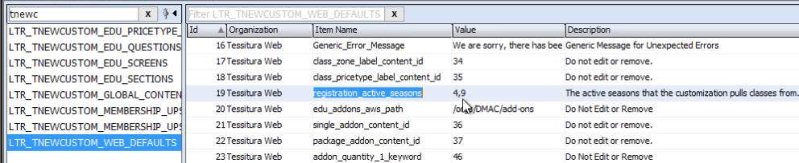
Note: If selling more than one season, enter multiple IDs as a comma delimited list. Do not keep old seasons listed here as it may negatively impact site performance.

Price Type Configuration
GoTo Menu > System Tables > LTR_TNEWCUSTOM_EDU_PRICETYPE_AFFILIATIONS
In this system table, the price types used for the package or performance are associated to the applicable Adult or Child affiliation. For example, create an entry for Child to ensure that students (by birthdate) will always pay the child rate, and an accompanying Adult could use a different rate.
Note: If you add or change price types in future seasons, you will need to add or edit applicable rows in this table to display the new price types.

Keyword Configuration
GoTo Menu > Ticketing Setup > Production Elements or Packages
Keywords are used to enable registration functionality for a performance or fixed-seat package, as well as additional features such as forms, validation, and filters.
Applicable keywords are added to any of the four production elements from the Keywords tab of the product element detail screen.
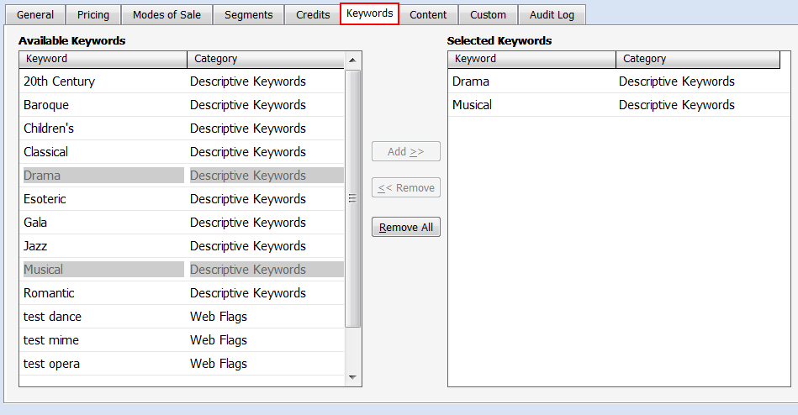
Registration
(Required) This keyword must be applied to a class performance or fixed-seat package to trigger the customization.
Registration Form
(Optional) Keywords with the Registration Form category are used to group questions together. Multiple form keywords can be applied to a single class.

Student Registration Grade (Grade Validation)
(Optional) Keywords with the Student Registration Grade category are used to only allow students from a particular grade to register (i.e. grade validation). If a class requires grade validation, then all valid grade keywords should be added to the event. For example, if a class has the requirement for grades 4th through 6th grade, the 4th, 5th, and 6th grade keywords should be applied to the class. LTR_TNEWCUSTOM_EDU_KW_GRADE
Add-on Max Quantity of 1
(Optional) This keyword is used in the case of an add-on item where the customer should only select a quantity of one (e.g. before and after care). When this keyword is applied, the quantity selection dropdown will not be displayed, and only one seat be added to the cart.
Note: This keyword only hides the quantity dropdown from display – it does not prevent the customer from returning to the add-on screen and adding a second seat.
Class Filter
(Optional) Keywords with the Class Filter category can be applied to classes that allow customers to filter available classes in the class selection drop down on the Participant First page (e.g. genre, grades, ages, locations).

Content Configuration
GoTo Menu > Ticketing Setup > Production Elements or Packages
Content values on a performance or fixed-seat package can extend registration functionality by displaying additional information relevant to the item.
Content can be added to any of the four production elements from the Content tab of the product element detail screen.
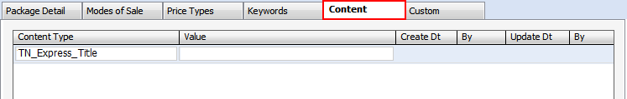
Min/Max Class Age (Year/Months)
This content entry will enable age validation for the class using birthdates. Age may be expressed in years or months.
- Min Class Age (Year) or Min Class Age (Months) – enter the minimum age value allowed for the class using numbers only
- Max Class Age (Year) or Max Class Age (Months) – enter the maximum age value allowed for the class using numbers only
Tip: Months are typically used for classes with an age requirement of younger than 2 years old.
Age as of Date
This content entry will override the default behavior for calculating class age validation using birthdates. The value for the content entry should be the date from which age validation should be calculated.
Note: Without a content entry, default age validation is calculated using the date of the performance or, within a package, the date of the earliest performance.
Class/Add-on Price Type Label
This content entry will override the default label for the price type dropdown, which is displayed when the class or add-on has more than one price type available for the customer to select.
Note: This content only modifies the label on the Participant First and Add-on pages, and does not affect any standard TNEW pages.
Class/Add-on Zone Label
This content entry will override the default label for the price zone dropdown, which is displayed when the class or add-on has more than one price zone available for the customer to select.
Note: This content only modifies the label on the Participant First and Add-on pages, and does not affect any standard TNEW pages.
Single Registration Add-ons
This content entry will trigger display of add-on performances for customer selection when the class is added to the cart. The value for the content entry is the performance ID (found on the General tab for the performance in Production Elements). If you wish to display multiple add-ons for the same class, enter the value as a comma separated list of the add-on performance IDs.
Package Registration Add-ons
This content entry will trigger display of add-on fixed-seat packages for customer selection when the class is added to the cart. The value for the content entry is the package ID (found on the Package Detail tab for the package in Ticketing Setup). If you wish to display multiple add-ons for the same class, enter the value as a comma separated list of the add-on package IDs.
EDU Dropdown Title
This content entry is only for use when the TN_Express_Title content value contains HTML tags. Entering a text-friendly value here will prevent the HTML tags from displaying in the class list drop down on the Participant First page.
Standard Display Content
These optional content entries can enhance display of your event/item or package, particularly on the Participant First page.
Note: TNEW v6 uses these same content entries on the Content tab of performances and packages to record some product details for display on the site and to trigger certain site functionality. Currently, TNEW v7 uses these entries for packages only.
- TN_Express_Title – An alternate title for display when the standard performance or package description in Tessitura is not customer-friendly.
- TN_Express_Time_Date_Display - When set to ShowDateOnly, the date is listed but the time is not listed. When set to DontShowDateTime, neither the date nor the time is listed. When set to ShowDateTime, the date and time are both listed.
- TN_Express_Prod_Synopsis (for performances)
TN_Express_Sub_Synopsis (for packages) – The description of the class.
- TN_Express_ProdSeas_Img (for performances)
TN_Express_Sub_Img (for packages) – Fully-qualified URL of image to be displayed. Images should be in either .GIF or .JPG format.

Form Configuration
GoTo Menu > System Tables
A predefined set of questions can be displayed on the Form/Waiver page for customers to complete before checkout. This can range from a single question (e.g., Policy Agreement checkbox) to a multi-page form divided into sections.
Forms are simply a collection of questions that make class administration and adding questions easier for your organization.
For customer display, take the time to organize questions into sections – and sections into a page (or multiple pages) – to make form completion easier for your patrons.
Note: Question data in the Tessitura constituent record is organized by section.

Registration Form

To setup questions and forms:
- Create individual questions by adding one row per question in the system table LTR_TNEWCUSTOM_EDU_QUESTIONS.
- Define the forms which will group sections and questions in the system table LTR_TNEWCUSTOM_EDU_FORM. These are used in Step 4, and as keywords to attach questions in bulk to performances and fixed-seat packages.
- Define the sections you would like to display as headers for questions in the system table LTR_TNEWCUSTOM_EDU_SECTIONS. These are used in Step 4.
- Connect the forms, pages, sections, and questions together in LTR_TNEWCUSTOM_EDU_FORM_QUESTIONS. Questions can be sorted within each section, and the sections can also be sorted per page and form.
Note: It is possible to make a question dependent on a response from another question. Dependent questions should be on the same page and in the same section, with the dependent question sorted below the triggering question.
- Test the form and registration on your TN Express Web site, and check that the data displays as expected on the Edu Screen on the custom tab in Tessitura.
Important: The input type of a question should not be altered once a question has been used with a live form. If a change is necessary, the question should be inactivated and recreated with the new input type. Failure to do so will cause errors for accounts that had completed the question before the change.

System Tables
Most system table entries are configured during initial installation of the customization. As program offerings and forms/waivers change, you may need to add or edit entries in some of the system tables documented below.
All tables can be found in the Tessitura menu under GoTo > System Tables.

LTR_TNEWCUSTOM_EDU_AFFILIATION_OPTIONS
Entries in this table are used to populate adult/child affiliate account information when adding a new registrant on the Recipient Page or Participant First Page.
Organization – The organization value used by your TN Express Web site.
Affiliation – Values: Adult, Child. Dropdown of available affiliations for the customization.
Alias – Label for affiliation dropdown when creating new students.
Ask Birthdate – Values: Yes, No, Optional. If set to Yes, input is displayed and required. If set to no, input is not displayed. If set to Optional, input is displayed but not required.
Ask Email – Values: Yes, No, Optional. If set to Yes, input is displayed and required. If set to no, input is not displayed. If set to Optional, input is displayed but not required.

LTR_TNEWCUSTOM_EDU_PRICETYPE_AFFILIATIONS
Entries in this table are used to display applicable price types when adding a class.
On the Participant First page, only the affiliated price types and performances will display when the student is selected.
On the Recipient page, only the associated affiliate accounts will display when a price type is selected and added to the cart.
Organization – The organization value used by your TN Express Web site.
Price Type – A dropdown to select the price type used for the customization.
Affiliation – A dropdown to select the affiliation associated with the selected price type from LTR_TNEWCUSTOM_EDU_AFFILIATION_OPTIONS. Used to limit available price types based on the participant selected.
Note: If a particular price type can be used by both child and adult affiliations, then there must be two rows for the price type – one for Adult and one for Child.

LTR_TNEWCUSTOM_EDU_GRADES
Entries in this table are displayed for selection during participant registration and are used for grade validation when displaying eligible classes.
Grade – Customer-facing description of applicable class grades (e.g., 4th Grade)
Sort Order – An integer for ranking the sort order of class grades within the dropdown.

LTR_TNEWCUSTOM_EDU_KW_GRADE
Entries in this table can be applied to a performance or package as a keyword for use in grade validation.
Keyword – The keyword associated to the selected grade. These keywords use the category Student Registration Grade.
Grade – Dropdown of values from LTR_TNEWCUSTOM_EDU_GRADES

LTR_TNEWCUSTOM_EDU_FORM
Entries in this table can be applied to a performance or package as a keyword for use in selecting forms for display. Forms are associated with questions in the system table LTR_TNEWCUSTOM_EDU_FORM_QUESTIONS.
Organization – The organization value used by your TN Express Web site.
Keyword – The keyword associated to the selected form. These keywords use the category Registration Form.
Form Desc – A short description of the form.

LTR_TNEWCUSTOM_EDU_SECTIONS
Entries in this table are used to organize form questions defined in the system table LTR_TNEWCUSTOM_EDU_FORM_QUESTIONS.
Organization – The organization value used by your TN Express Web site.
Title – The title of the section.
Additional Text – (Optional) Text displayed below the title of the section.

LTR_TNEWCUSTOM_EDU_QUESTIONS
Entries in this table are used to create the individual questions for display. These questions are associated with forms in the system table LTR_TNEWCUSTOM_EDU_FORM_QUESTIONS.
Organization – The organization value used by your TN Express Web site.
Input Type – Values: Dropdown, Radio Option, Checkbox, Text, Text Area, Number, Currency, Date, Email. This is the format for the type of input displayed to a customer. Validation checks will require the customer to correctly enter data in the form if the selected input type is number, currency, date, or email.
Important: The input type of a question should not be altered once a question has been used with a live form. If a change is necessary, the question should be inactivated and recreated with the new input type. Failure to do so will cause errors for accounts that had completed the question before the change.
Question Group – Short description of the question category. Only used to sort questions in a logical order in the system tables. Not seen by the customer.
Question Short Desc – (recommended) When the Question Desc is greater than 50 characters, this shorter description will instead be displayed on the Tessitura custom screen.
Important: This should be a unique description so as to not be confused with other questions. Example: Instead of “I Agree”, use “I Agree to the photo release waiver”.
Question Desc – (required) The actual question displayed to customers online and displayed on the custom screen in Tessitura. However, if greater than 50 characters, the Question Short Desc will be displayed instead on the Tessitura custom screen.
Note: This should be a unique description so as to not be confused with other questions. Example: Instead of “I Agree”, use “I Agree to the photo release waiver”.
Question Pre Text – (optional) Instructional text displayed below the question online.
Ref Tbl – The table or view name from which lookup values are pulled (dropdowns and radio options only).
Ref IdCol – The ID column number in the table or view entered in Ref Tbl. This column is only used if Ref Tbl is used.
Ref DescCol – The column number in the table or view entered in Ref Tbl where value descriptions are stored. These values are the options visible to the user. This column is only used if Ref Tbl is used.
Ref Where – A SQL “WHERE” expression used to filter the values from the table or view entered in Ref Tbl. This column is only used if Ref Tbl is used.
Note: Do not include the word “WHERE”, as it is prepended to the SQL when the code is run.
Ref Sort – An expression used to sort the dropdown values. If no expression is entered, the values are sorted alphabetically by description. This column is only used if Ref Tbl is used.
Per Class – When checked, this question will be asked separately within the form for each class (e.g. – obtaining travel info or other details that may change for every class).
Waiver – When checked, a history of the Question Desc and Question Pre-Text will be maintained after any change (e.g., policies and procedures; photo release).
Note: This is intended for use with questions that contain legal content, where it is important to know the exact content displayed within the agreement.
Db Location – Values: Custom Screen, Research Note, Attribute, or Gender Field (on the constituent screen). The location where the question response is stored.
Db Location Id – If location above is Custom Screen, Research Note or Attribute, the desired option must be selected here.

LTR_TNEWCUSTOM_EDU_FORM_QUESTIONS
Entries in this table are used to connect individual questions and group together within a form (or group by sections within a form).
Organization – The organization value used by your TN Express Web site.
Form Id – Comes from LTR_TNEWCUSTOM_EDU_FORM
Question Id – Comes from LTR_TNEWCUSTOM_EDU_QUESTIONS
Page Number – The Form/Waiver page number where this question will appear.
Section Id – Comes from LTR_TNEWCUSTOM_EDU_SECTIONS
Section Sort – The section sort order within the page, ranked by integer (1 = first).
Question Sort – The question sort order within the section, ranked by integer (1 = first).
Required – If checked, the question will be required.
Dependent Question Id – Used to display the question only if another question matches a specific value. Selecting a question from this dropdown means display of the current question row will be dependent on the selected question equaling the value defined below.
Dependent Question Value – Used to display the question only if another question matches a specific value. Display of the current question row is dependent on the selected question above having a customer response equal to this value.
Example A:
If the selected dependent question is a checkbox, and the current question is to be displayed when the checkbox is checked, the value should be “Y” (no quotes). If it should be displayed when the checkbox is unchecked, the value should be “N” (no quotes).
Example B:
If the selected dependent question is a radio option or drop down, the value should be the description for the option. So if the current question should be displayed only if the user selects the option “blue”, then the dependent question value should be “blue” (no quotes).

LTR_TNEWCUSTOM_GLOBAL_CONTENT
Entries in this table are used for editing content for all TNEW Customizations. Caution should be used when modifying this table.
Note: Rows should not be added or deleted in this table. Only the Value and Button URL columns should be edited. Any other modifications could break the customization.
Organization – The organization value used by your TN Express Web site.
MOS – The applicable Mode of Sale for the content. If blank, the content will apply to any mode of sale used by the customer on the site.
Module – Values in this column represent pages within the customization. For the education registration customization, the following modules are used:
- Edu_class_recipient
- Edu_participant
- Edu_addons
- Edu_registration_summary
- Edu_registration_form
Item – Description of the element on the page where the content value can be changed. Used to updated page titles, messages, buttons, and labels. Contents vary by customization.
Value – The desired content for the item. Tokens can also be used in place of content that will be dynamically replaced with the desired value. (e.g., for the item age_year_error_msg in the edu_class_recipient module, you can use the value “Required age is between {min_age} and {max_age} years old.”)

Module | Item | Available Token(s)
edu_class_recipient | age_year_error_msg | {min_age}  {max_age}
edu_class_recipient | age_month_error_msg | {min_age}  {max_age}
edu_participant | summary_display | {first_name}  {last_name}  {class}
edu_participant | grade_select_lbl | {class_dt}
edu_registration_form | form_heading | {name}
Button URL – A customized redirect URL. Use this field to redirect customers to a different page (e.g., class catalog) when they have removed a class or wish to register a participant for another class. For the education registration customization, the following module/items can have customizable button URLs.
- edu_class_recipient > remove_class_button
- edu_registration_summary > registration_class_button

LTR_TNEWCUSTOM_ WEB_DEFAULTS
Entries in this table are used for editing settings for all TNEW Customizations. Caution should be used when modifying this table.
Note: Rows should not be added or deleted in this table. Only the Value column should be edited, and only for items where the description is not “Do not Edit or Remove”. Any other modifications could break the customization.
Organization – The organization value used by your TN Express Web site.
Item Name – Description of the setting. Used to enable/disable customizations, as well as update settings such as the cart timer and the list of active seasons. Contents vary by customization.
Value – The desired setting for the item. Most entries are used to connect to other IDs in your system and should not be edited. However, some entries such as the cart timer and the list of active seasons can (and should) be edited as needed.
Description – Information related to the values allowed for the row item. Most entries are marked as “Do not Edit or Remove”.

LTR_TNEWCUSTOM_EDU_SCREENS
Note: Do not modify entries in this table – reserved for future use.

Sample Site Screenshots

TNEW Event/Item Page
Standard TNEW Event/Item Page Documentation
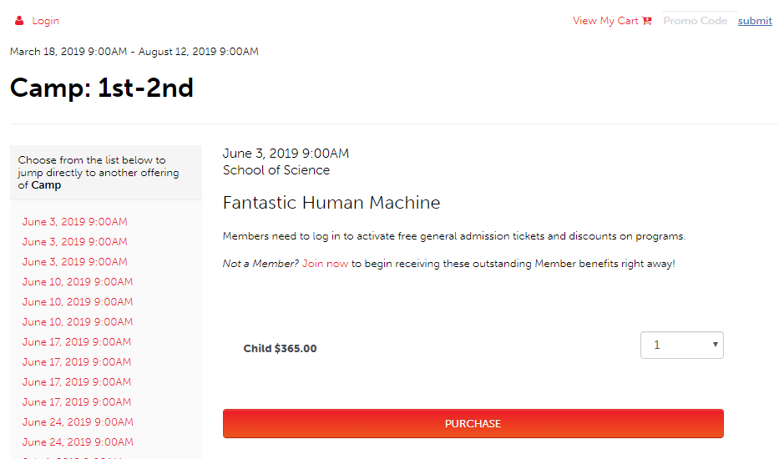

TNEW Login Page
Standard TNEW Login Page Documentation
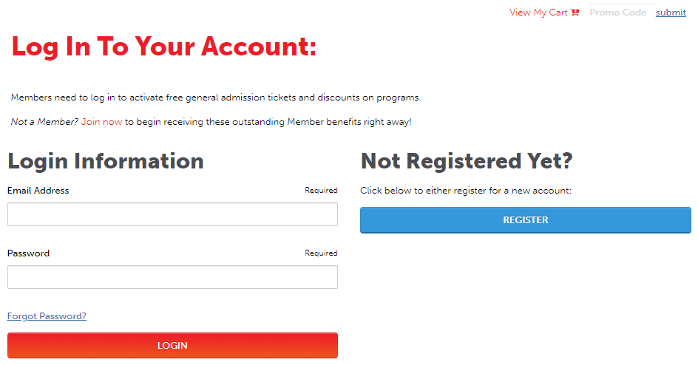

TNEW Create Account Page
Standard TNEW Create Account Page Documentation
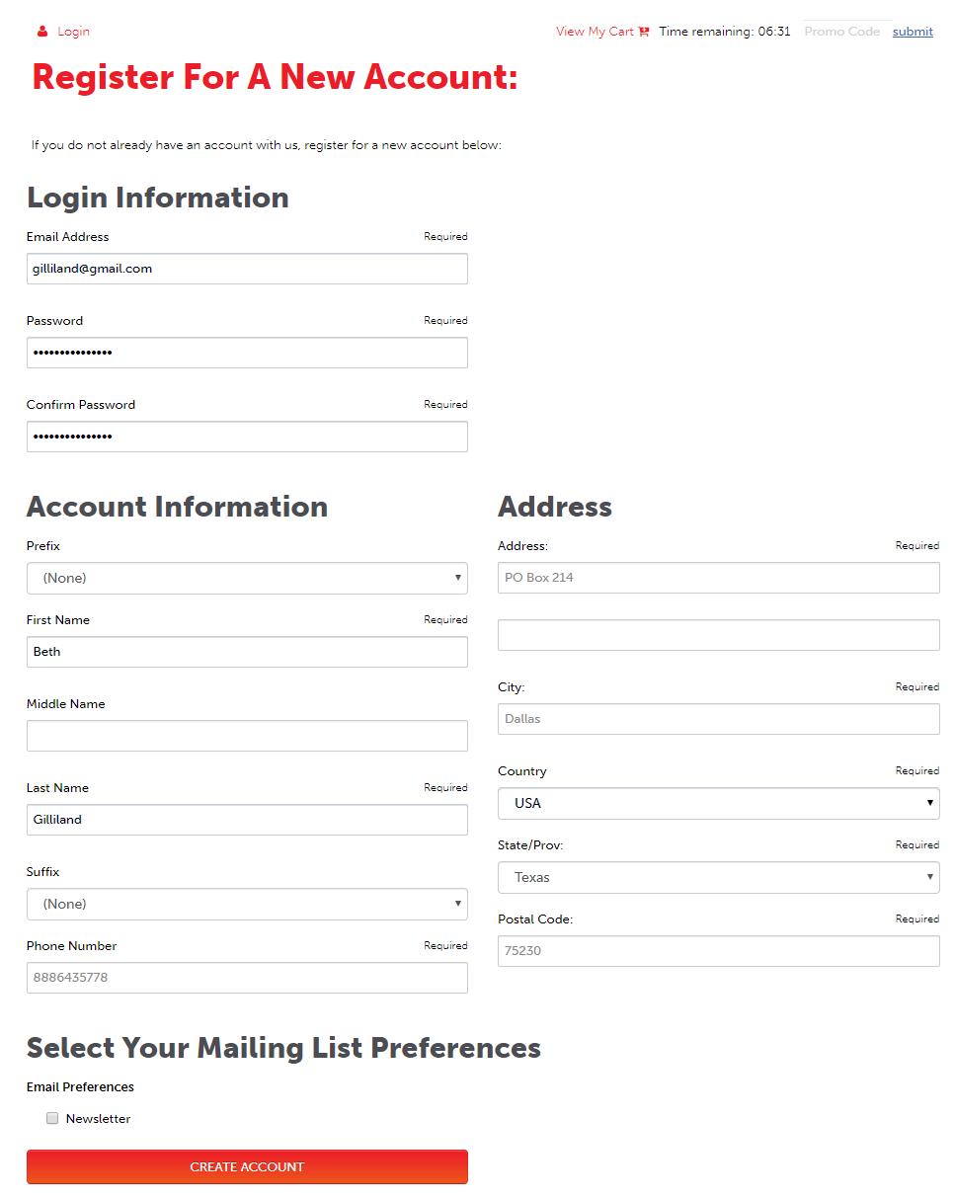

Recipient Page
Selecting a Recipient
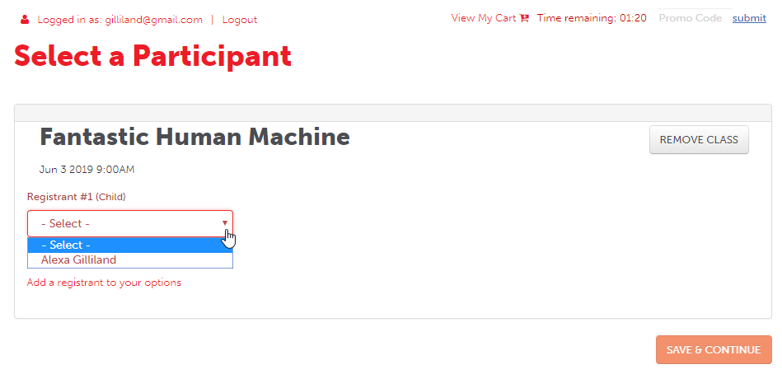
Adding a Child
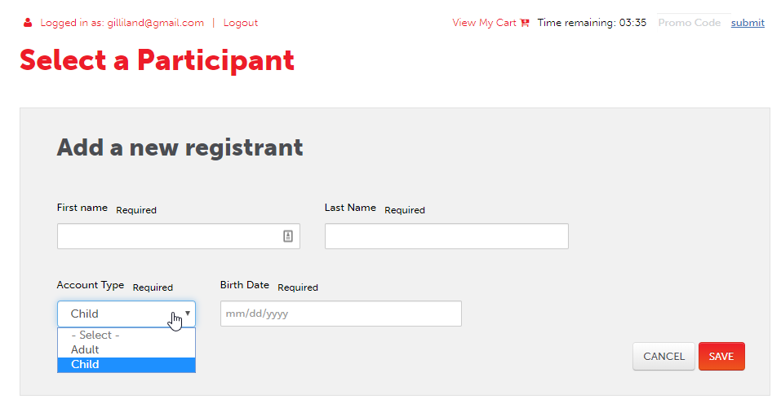
Adding an Adult
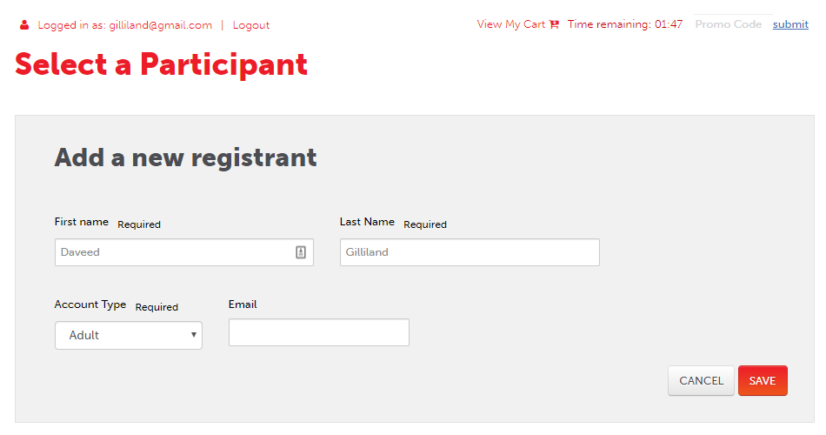

Participant First Page
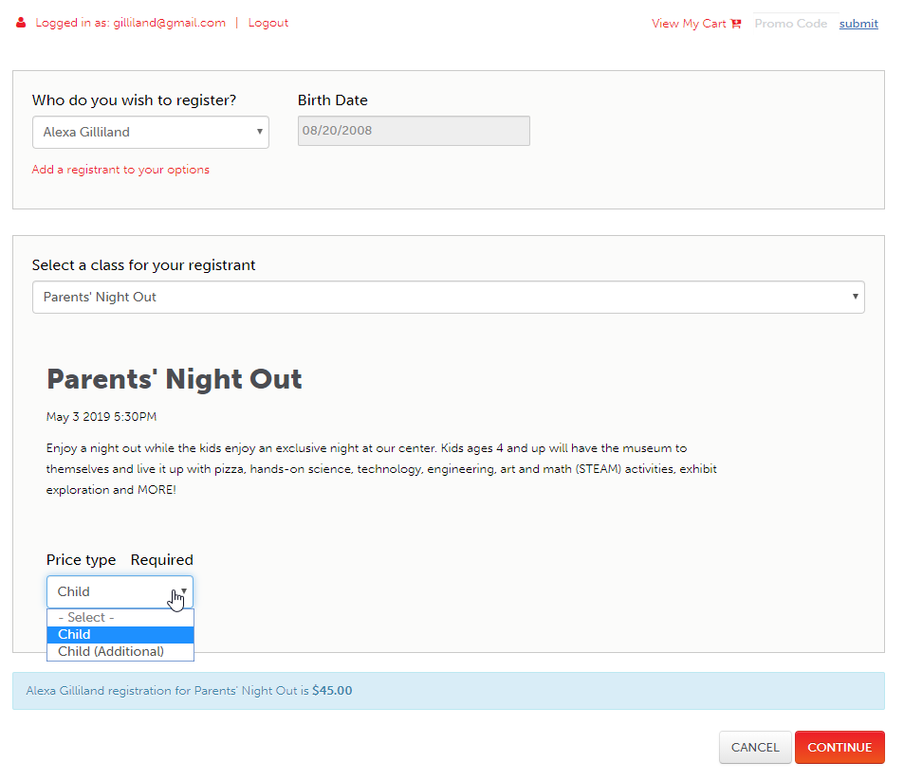

Add-on Page
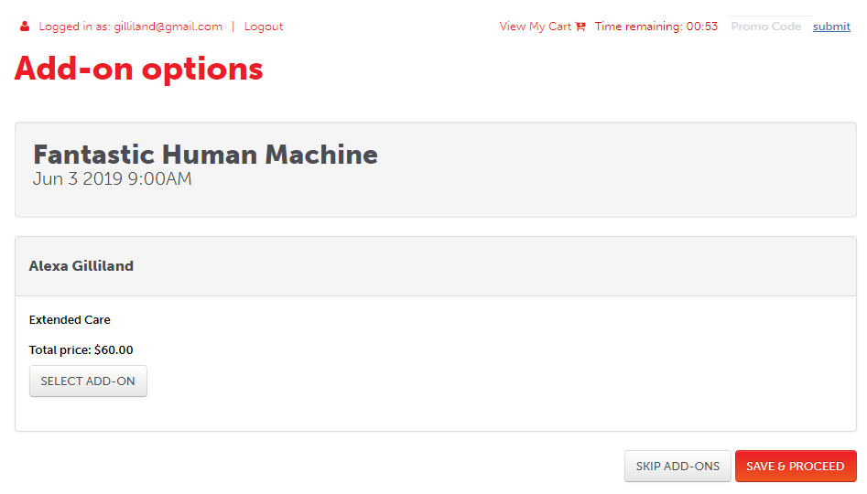

Summary Page
Displays a summary of each class, including costs, participants and add-ons. Allows the customer to add another participant, another class, or continue to checkout.
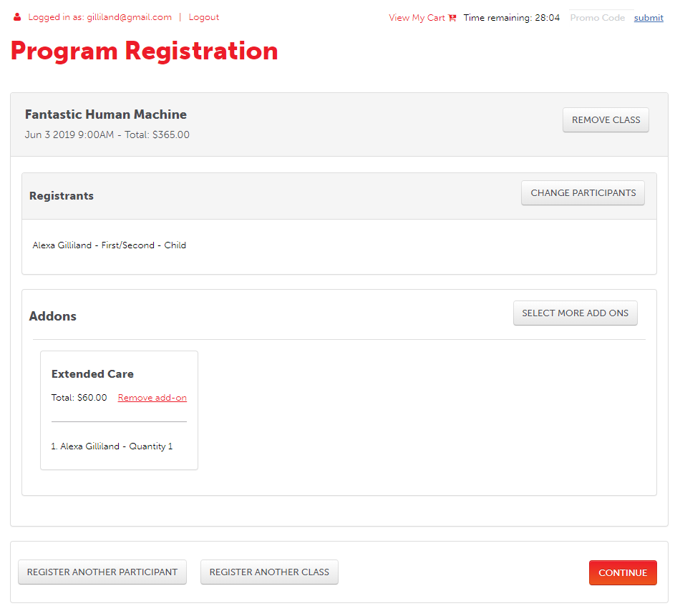

Form/Waiver Page
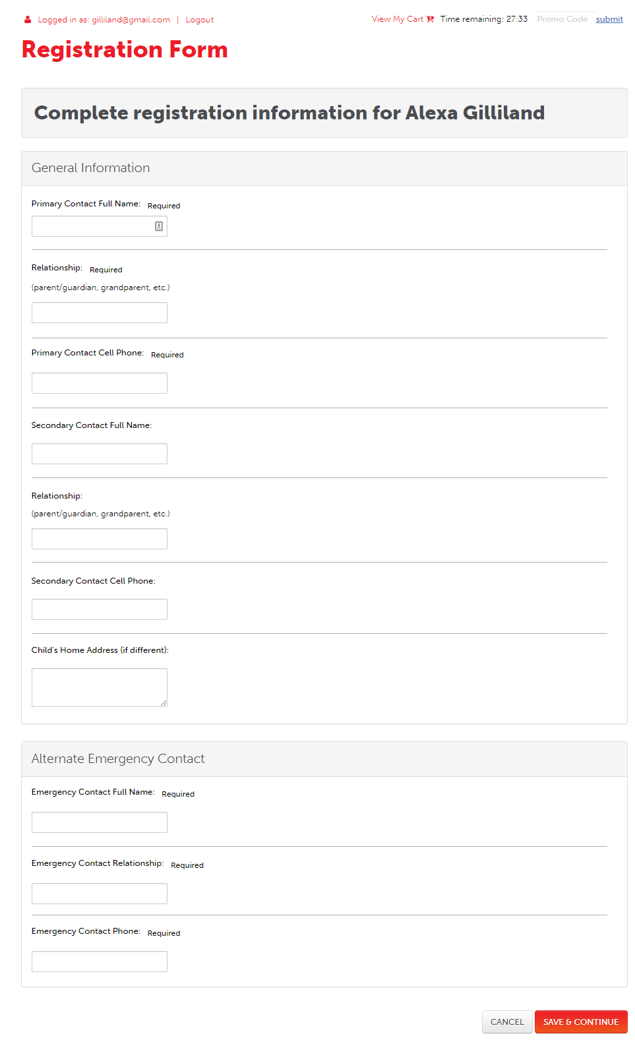

TNEW Cart Details Page
Standard TNEW Cart Details Page Documentation
