- Run the report, click the save icon and choose a file type.

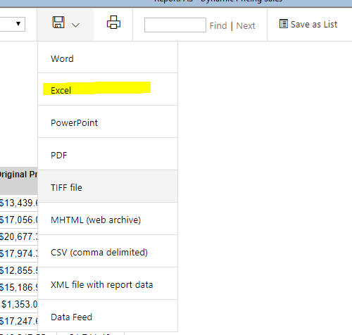

- A dialoge should pop up notifying you of the applicaion to access the files. Choose “Permit all access”.
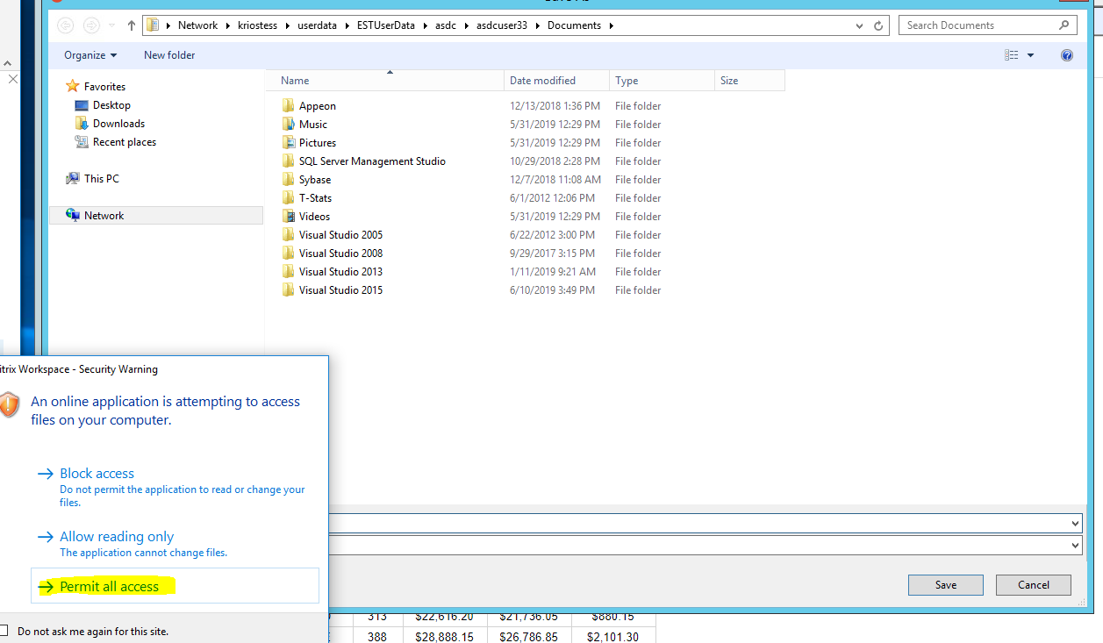

- Expand “This PC”, select the drive, navigate to the appropriate location and click save.
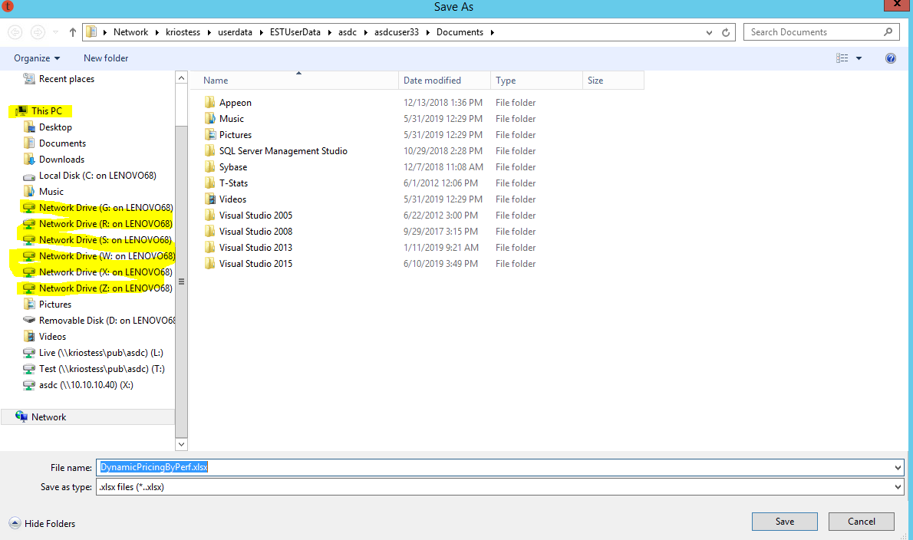

Please note: If you do not receive the permit access option; you must adjust your citrix setting. In the tray on the lower right of your screen, right click the citrix receiver icon and select connection center. Click preferences, select “read & right” radio and click “ok”. Log out and back in. You should see the prompt when saving.

